BUILD PHYSICS | GUIDED INVESTIGATION
ATWOOD MACHINE
Mass difference, total mass, tension, and acceleration
Name: ____________________________ | Period: ____________ | Date: ______________

INVESTIGATION QUESTION How do mass difference and total mass determine the acceleration of an Atwood machine?
TIME  30 minutes | SIMULATION  BuildPhysics > Atwood machine | UNIT 2  Force & Translational Dynamics
Learning targets
• Apply Newton's second law to a two-mass system.
• Test acceleration while total mass or mass difference is controlled.
• Compare rope tension with the weights of the two masses.
Model before you measure
The pulley is massless in this preset. Label the heavier side m₁ and choose its downward direction as positive. | a = (m₁ − m₂)g/(m₁ + m₂)
Important: Use g = 9.8 m/s². Keep both masses clear of the pulley and floor, and reset before each run.
Pre-lab prediction | 4 minutes
1. What happens when the two masses are equal?
__________________________________________________________________________________________
2. If total mass stays constant, how should acceleration change as the mass difference grows?
__________________________________________________________________________________________
3. If mass difference stays constant but total mass increases, how should acceleration change?
__________________________________________________________________________________________

PART A Keep total mass constant
Setup | 3 minutes
□ Load Atwood machine. Confirm the pulley is massless and the rope is connected to both masses.
□ Set m₁ and m₂ so their total is 3.0 kg for every Part A trial.
□ Select a mass to read acceleration and select the rope or mass to read tension.
□ Reset, run briefly, pause before either mass reaches an obstacle, and record.
Control: Keep m₁ + m₂ = 3.0 kg. The independent variable is the mass difference m₁ − m₂.
Data table | 10 minutes
m₁  (kg) | m₂  (kg) | m₁ − m₂  (kg) | Predicted a  (m/s²) | Measured a  (m/s²)
1.50 | 1.50
1.75 | 1.25
2.00 | 1.00
2.25 | 0.75
2.50 | 0.50
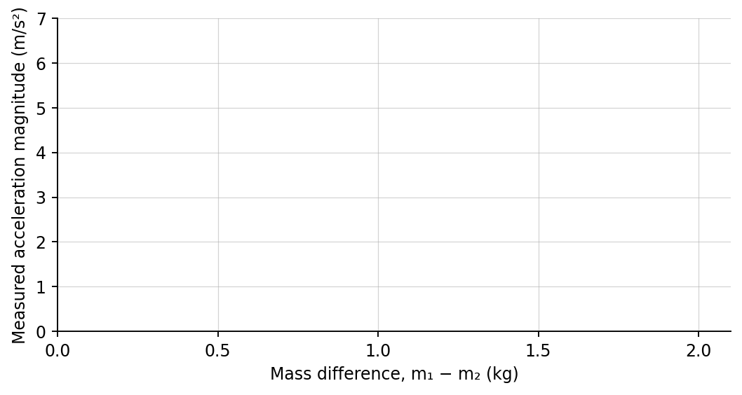
4. Plot measured acceleration versus mass difference. Draw a best-fit line.

PART B Keep mass difference constant
Total-mass test | 6 minutes
Control: Keep m₁ − m₂ = 1.0 kg while increasing both masses.
m₁  (kg) | m₂  (kg) | Predicted a  (m/s²) | Measured a  (m/s²)
2.0 | 1.0
3.0 | 2.0
4.0 | 3.0
Analysis | 8 minutes
5. What did the slope in Part A represent when total mass was 3.0 kg?
_______________________________________________________________________________________________
6. Why did equal masses produce zero acceleration even though both weights were nonzero?
_______________________________________________________________________________________________
7. Why did acceleration decrease in Part B while the mass difference stayed 1.0 kg?
_______________________________________________________________________________________________
8. For the 2.0 kg and 1.0 kg trial, calculate the predicted rope tension using either mass.
_______________________________________________________________________________________________
Claim-Evidence-Reasoning conclusion
Evaluate this statement: “Only the difference between the two masses determines an Atwood machine's acceleration.”
CLAIM | Accept, reject, or revise the statement.
EVIDENCE | Cite at least two measurements or graph features.
REASONING | Connect your evidence to the force model and Newton's laws.
Exit ticket
Predict the acceleration of an ideal Atwood machine with masses 3.0 kg and 1.0 kg. Use g = 9.8 m/s².
____________________________________________________________________________________________
____________________________________________________________________________________________

