BUILD PHYSICS | GUIDED INVESTIGATION
BALLISTIC PENDULUM
Momentum during impact and energy during the swing
Name: ____________________________ | Period: ____________ | Date: ______________

INVESTIGATION QUESTION Can the projectile's launch speed be determined from the pendulum's maximum rise?
TIME  30 minutes | SIMULATION  BuildPhysics > Ballistic pendulum | UNIT 4  Linear Momentum
Learning targets
• Separate a ballistic-pendulum event into collision and swing stages.
• Use momentum conservation during the perfectly inelastic collision.
• Use mechanical energy during the upward swing to infer launch speed.
Model before you measure
The projectile sticks to the pendulum bob. Momentum applies during impact; mechanical energy applies after impact. | m_{p}v_{i} = (m_{p} + m_{b})V ½(m_{p} + m_{b})V² = (m_{p} + m_{b})gΔh
Important: Use g = 9.8 m/s². Do not apply mechanical-energy conservation across the collision itself.
Pre-lab prediction | 4 minutes
1. Which speed is larger: the projectile speed before impact or the combined speed just after impact?
__________________________________________________________________________________________
2. If the projectile speed increases, what should happen to maximum rise?
__________________________________________________________________________________________
3. Why is kinetic energy not conserved during the sticking collision?
__________________________________________________________________________________________

PART A Change projectile launch speed
Setup | 3 minutes
□ Load Ballistic pendulum. Record projectile mass mₚ and pendulum-bob mass m_b.
□ Turn on momentum and energy totals. Graph pₓ, speed, and y-position.
□ Set the projectile to each listed initial speed while keeping both masses fixed.
□ Reset, run through impact and the first swing, pause at maximum rise, and record the values.
Two stages: Record the combined speed immediately after impact and the center-of-mass vertical rise from just after impact to the turning point.
Data table | 10 minutes
Projectile vᵢ  (m/s) | vᵢ²  (m²/s²) | Combined V after impact  (m/s) | Maximum rise Δh  (m) | Calculated vᵢ  (m/s) | Measured total pₓ before  (kg·m/s)
4.0
6.0
8.0
10.0
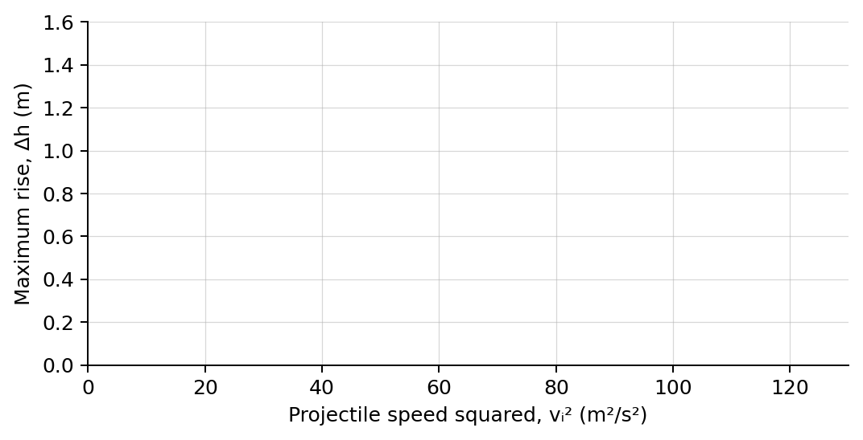
4. Plot maximum rise versus projectile speed squared. Draw a best-fit line.

PART B Change pendulum mass
Mass test | 7 minutes
Fixed launch: Use one projectile speed from Part A and keep projectile mass constant.
Pendulum mass m_b  (kg) | Combined speed V  (m/s) | Maximum rise Δh  (m) | Calculated projectile speed  (m/s)
1.0
2.0
3.0
4.0
Analysis | 7 minutes
5. What relationship did your graph show between Δh and vᵢ²?
_______________________________________________________________________________________________
6. Why must the collision and swing be analyzed with different conservation laws?
_______________________________________________________________________________________________
7. How did increasing pendulum mass affect combined speed and maximum rise?
_______________________________________________________________________________________________
8. Compare the calculated projectile speeds with the simulation settings.
_______________________________________________________________________________________________
Claim-Evidence-Reasoning conclusion
Evaluate this claim: Mechanical energy is conserved from immediately before impact to the maximum swing height.
CLAIM | Accept, reject, or revise the statement.
EVIDENCE | Cite at least two measured trials or graph features.
REASONING | Separate the collision interval from the swing and cite momentum and energy evidence.
Exit ticket
A projectile sticks to a pendulum and the combined system rises. State the order in which momentum and energy equations should be used.
_______________________________________________________________________________________________
_______________________________________________________________________________________________

