BUILD PHYSICS | GUIDED INVESTIGATION
CIRCULAR ORBIT
Gravitational force, orbital speed, and orbital radius
Name: ____________________________ | Period: ____________ | Date: ______________

INVESTIGATION QUESTION What tangential speed produces a circular orbit at a given radius?
TIME  30 minutes | SIMULATION  BuildPhysics > Circular orbit | UNIT 2  Force & Translational Dynamics
Learning targets
• Classify orbital paths produced by different initial tangential speeds.
• Find circular speeds at several orbital radii.
• Connect gravity with centripetal acceleration.
Model before you measure
The satellite begins 4.5 m from the central body. The baseline circular speed is approximately 3.0 m/s in the simulation scale. | F_{g} = mv²/r v_{c}²r = constant
Important: Gravity toward the central body supplies the centripetal force. Use g = 9.8 m/s² only for near-Earth problems; this preset uses its own central gravitational field.
Pre-lab prediction | 4 minutes
1. What happens if the satellite's tangential speed is slightly less than circular speed?
__________________________________________________________________________________________
2. What happens if the speed is slightly greater but still below escape speed?
__________________________________________________________________________________________
3. If orbital radius increases, should circular speed increase or decrease?
__________________________________________________________________________________________

PART A Change tangential speed and classify the path
Setup | 3 minutes
□ Load Circular orbit. Turn on trails and select the satellite.
□ Keep the starting radius at 4.5 m and set vₓ = 0. Change only the positive tangential vᵧ.
□ Reset, run long enough to reveal the path, and classify it.
□ Estimate the smallest and largest radius from the grid or radial readout.
Data table | 10 minutes
Initial tangential speed  (m/s) | Minimum radius  (m) | Maximum radius  (m) | Path classification
2.2
3.0
3.6
4.2
4.5
Trail sketches | 3 minutes
Below circular speed | Circular speed | Above circular speed
Sketch | Sketch | Sketch

PART B Change radius and find circular speed
Radius test | 8 minutes
Procedure: Place the satellite at each radius on the +x side of the central body. Adjust positive vᵧ until the trail is approximately circular.
Radius r  (m) | Circular speed v  (m/s) | v²  (m²/s²) | 1/r  (1/m) | v²r
3.0
4.5 | 3.0
6.0
8.0
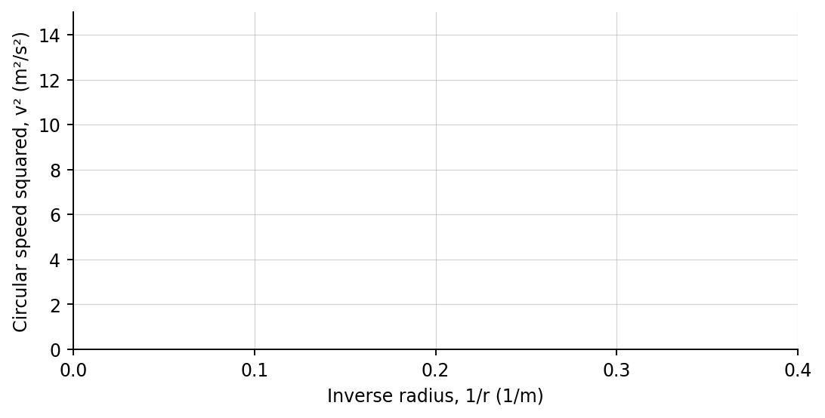
4. Plot v² versus 1/r. Draw a best-fit line.
Analysis | 6 minutes
5. What path occurred below, at, and above circular speed?
_______________________________________________________________________________________________
6. What does the slope of the v²-versus-1/r graph represent for this central body?
_______________________________________________________________________________________________
7. Why is the satellite accelerating even when its orbital speed is constant?
_______________________________________________________________________________________________
Claim-Evidence-Reasoning conclusion
Evaluate this statement: “A satellite farther from the central body must move faster to remain in a circular orbit.”
CLAIM | Accept, reject, or revise the statement.
EVIDENCE | Cite at least two measurements or graph features.
REASONING | Connect your evidence to the force model and Newton's laws.
Exit ticket
If the orbital radius doubles around the same central body, by what factor does the circular speed change?
____________________________________________________________________________________________
____________________________________________________________________________________________

