BUILD PHYSICS | GUIDED INVESTIGATION
CONSERVATION OF ANGULAR MOMENTUM
Off-center impact, sticking collision, and final angular speed
Name: ____________________________ | Period: ____________ | Date: ______________

INVESTIGATION QUESTION How does impact point affect the final angular speed of a rotating system?
TIME  30 minutes | SIMULATION  BuildPhysics > Conservation of Angular Momentum | UNIT 6  Energy & Momentum of Rotating Systems
Learning targets
• Calculate angular momentum about a chosen axis.
• Test angular-momentum conservation during a sticking collision.
• Relate impact parameter and incoming speed to final angular speed.
Model before you measure
A moving disk strikes and sticks to a freely rotating disk. During the short collision, external torque about the central pivot is negligible. | L_{i} = mvb + I_{disk}ω_{i} L_{f} = I_{total}ω_{f}
Important: Measure impact parameter b as the perpendicular distance from the pivot to the incoming disk centerline. Angular momentum depends on the chosen axis.
Pre-lab prediction | 4 minutes
1. What happens to initial angular momentum as impact parameter increases?
__________________________________________________________________________________________
2. Predict the final angular speed for a direct hit through the pivot, b = 0.
__________________________________________________________________________________________
3. Is kinetic energy conserved when the disks stick together? Explain.
__________________________________________________________________________________________

PART A Change impact parameter
Setup | 3 minutes
□ Load Conservation of Angular Momentum. Record both masses, radii, the rotating disk inertia, and incoming speed.
□ Keep incoming speed and all object properties fixed.
□ Move the incoming disk vertically to create the listed impact parameters.
□ Reset, run through the sticking collision, and record angular momentum and final angular speed.
Sign convention: Choose counterclockwise as positive and record the sign of b, angular momentum, and angular speed consistently.
Data table | 10 minutes
Impact parameter b  (m) | Initial orbital L  (kg·m²/s) | Total L before  (kg·m²/s) | Total L after  (kg·m²/s) | Final ωf  (rad/s) | K after / K before
-2.0
-1.0
0.0
+1.0
+2.0
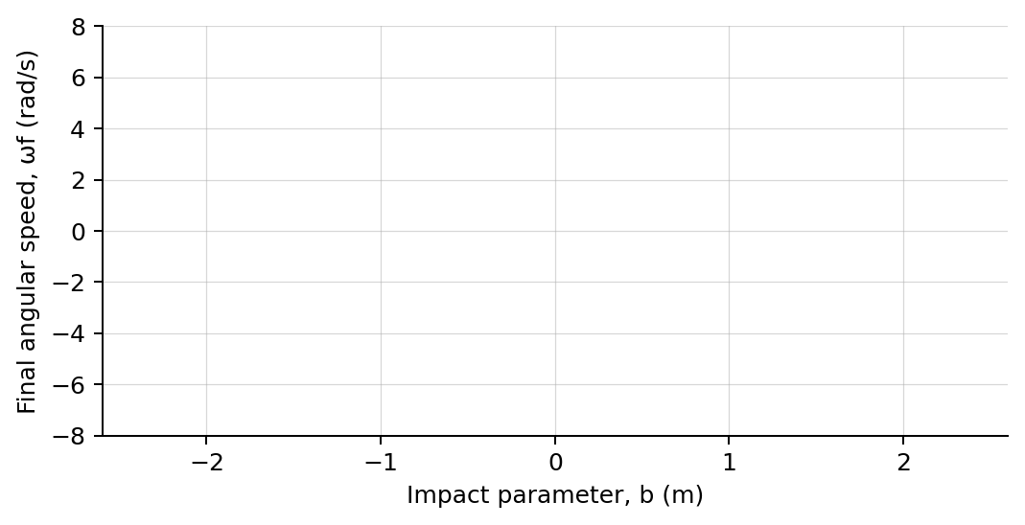
4. Plot final angular speed versus signed impact parameter. Draw a best-fit line.

PART B Change incoming speed
Speed test | 7 minutes
Fixed geometry: Choose one nonzero impact parameter and keep masses, radii, and all inertia values fixed.
Incoming speed  (m/s) | Initial angular momentum  (kg·m²/s) | Final angular speed  (rad/s) | Total angular momentum after  (kg·m²/s)
1.0
2.0
3.0
4.0
Analysis | 7 minutes
5. How closely was total angular momentum conserved across the collision?
_______________________________________________________________________________________________
6. How did impact parameter determine the magnitude and direction of final rotation?
_______________________________________________________________________________________________
7. What relationship did Part B show between incoming speed and final angular speed?
_______________________________________________________________________________________________
8. Why can angular momentum be conserved while kinetic energy decreases?
_______________________________________________________________________________________________
Claim-Evidence-Reasoning conclusion
Evaluate this claim: An off-center collision creates angular momentum only because the pivot exerts a torque during impact.
CLAIM | Accept, reject, or revise the statement.
EVIDENCE | Cite at least two measured trials or graph features.
REASONING | Use the system boundary, external torque about the pivot, and the equation L = mvb.
Exit ticket
A moving object passes twice as far from a pivot at the same speed. Predict its angular momentum about that pivot.
_______________________________________________________________________________________________
_______________________________________________________________________________________________

