BUILD PHYSICS | GUIDED INVESTIGATION
CONSTANT ACCELERATION
Position, velocity, and equal-time changes
Name: ____________________________ | Period: __________ | Date: ____________

INVESTIGATION QUESTION How do position and velocity change during motion with constant acceleration?
TIME  30 minutes | SIMULATION  BuildPhysics > Constant acceleration | UNIT 1  Kinematics
Learning targets
• Use x–t, vₓ–t, and aₓ–t data to identify constant acceleration.
• Relate the slope of a vₓ–t graph to acceleration.
• Test the relationships vₓ = vₓ₀ + aₓt and Δx = vₓ₀t + ½aₓt².
Model before you measure
Choose +x to the right.  Begin each trial from rest at the same position. | Constant-acceleration model  vₓ = vₓ₀ + aₓt  Δx = vₓ₀t + ½aₓt²
Use for this lab: g = 9.8 m/s². Gravity is balanced by the surface, so the measured horizontal acceleration is controlled separately.
Pre-lab prediction | 4 minutes
1. Describe the expected shapes of the x–t, vₓ–t, and aₓ–t graphs.
______________________________________________________________________________________________
______________________________________________________________________________________________
2. During equal time intervals, should the changes in velocity be equal? Explain.
______________________________________________________________________________________________

PART A One detailed constant-acceleration trial
Setup | 3 minutes
□ Load Constant acceleration. Select the Constant-acceleration block.
□ Open Analyze → Graph and display x, vₓ, and aₓ.
□ Use Set acceleration or the object controls to set aₓ = +2.0 m/s² and vₓ₀ = 0.
□ Reset, run for 2.0 s, and use the graph cursor to record the data below.
Time-series data | 8 minutes
t  (s) | x  (m) | vₓ  (m/s) | aₓ  (m/s²) | Δvₓ during  next 0.5 s | Δx during  next 0.5 s
0.0
0.5
1.0
1.5
2.0
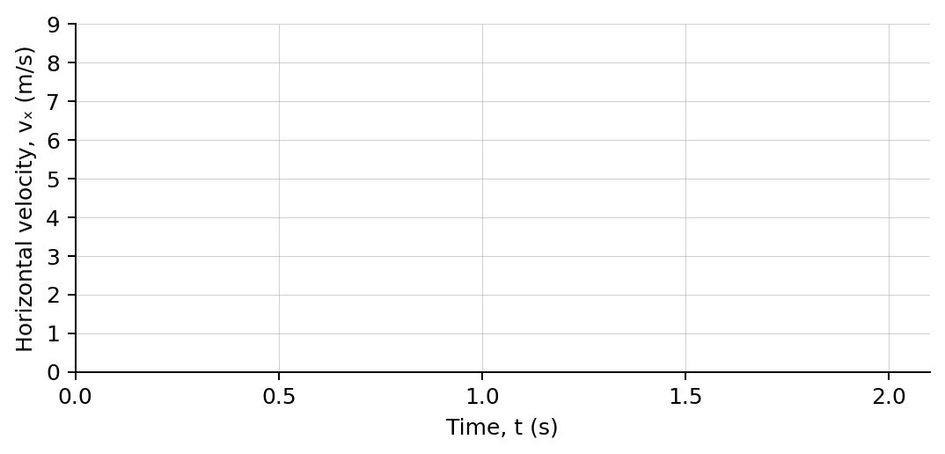
3. Plot vₓ versus t and draw a best-fit line. Calculate its slope.
______________________________________________________________________________________________
4. Compare the slope with the acceleration shown by BuildPhysics.
______________________________________________________________________________________________

PART B Change acceleration and test the model
Controlled trials | 8 minutes
Keep vₓ₀ = 0 and t = 2.0 s. Change only aₓ. Reset before each trial.
Trial | Set aₓ  (m/s²) | Measured vₓ  at 2.0 s | Measured Δx  at 2.0 s | Δvₓ/Δt  (m/s²) | 2Δx/t²  (m/s²)
1 | 1.0
2 | 2.0
3 | 3.0
4 | 4.0
Analysis | 7 minutes
5. What stayed constant in the vₓ–t data, and what changed when aₓ increased?
______________________________________________________________________________________________
6. Compare Δvₓ/Δt and 2Δx/t² with the acceleration you set. What pattern do you observe?
______________________________________________________________________________________________
______________________________________________________________________________________________
7. Why does an x–t graph curve upward even though acceleration is constant?
______________________________________________________________________________________________
8. At aₓ = 3.0 m/s², predict vₓ and Δx after 3.0 s from rest.
______________________________________________________________________________________________
______________________________________________________________________________________________
Claim-Evidence-Reasoning conclusion
Evaluate this statement: “Constant acceleration means an object travels equal distances during equal time intervals.”
CLAIM | Accept, reject, or revise the statement.
EVIDENCE | Cite at least two measurements or graph features.
REASONING | Connect your evidence to the kinematics model.
Exit ticket
A vₓ–t graph is a straight line with slope −1.5 m/s². Describe the object’s acceleration and how its velocity changes each second.
______________________________________________________________________________________________
______________________________________________________________________________________________

