BUILD PHYSICS | GUIDED INVESTIGATION
CONSTANT SPEED
Position, velocity, and the slope of an x–t graph
Name: ____________________________ | Period: __________ | Date: ____________

INVESTIGATION QUESTION How does position change when an object moves with constant velocity?
TIME  30 minutes | SIMULATION  BuildPhysics > Constant speed | UNIT 1  Kinematics
Learning targets
• Collect position-time data for several constant velocities.
• Use the slope of an x–t graph to determine horizontal velocity.
• Explain why the acceleration is zero even while the object is moving.
Model before you measure
Choose +x to the right.  Keep the surface frictionless and begin each trial from the same starting position. | Constant-velocity model  Δx = vₓΔt  slope of x–t = vₓ  aₓ = 0
Important: A steeper x–t line means a greater magnitude of velocity. A negative slope means motion in the −x direction.
Pre-lab prediction | 4 minutes
1. Sketch or describe the shape of an x–t graph for constant positive velocity.
______________________________________________________________________________________________
2. What should happen to the graph slope if the velocity doubles?
______________________________________________________________________________________________
3. Describe the vₓ–t and aₓ–t graphs for constant-speed motion.
______________________________________________________________________________________________

PART A Measure position and graph slope
Setup | 3 minutes
□ Load Constant speed. Select the Constant-speed block.
□ Open Data → Graph and display x, vₓ, and aₓ. Keep only x visible while finding each slope.
□ Use the velocity controls to set the listed vₓ. Reset before every trial and start at the same x-position.
□ Run each trial for 3.0 s, then pause and record the position values.
Consistent trials: Reset → set vₓ → Run → pause at 3.0 s → record. Keep gravity, surface, and starting position unchanged.
Data table | 10 minutes
Trial | Set vₓ  (m/s) | x at 0 s  (m) | x at 1 s  (m) | x at 2 s  (m) | x at 3 s  (m) | Graph slope  (m/s)
1 | 1.0
2 | 2.0
3 | 3.0
4 | 4.0
Slope calculation: slope = Δx/Δt = ______________________________
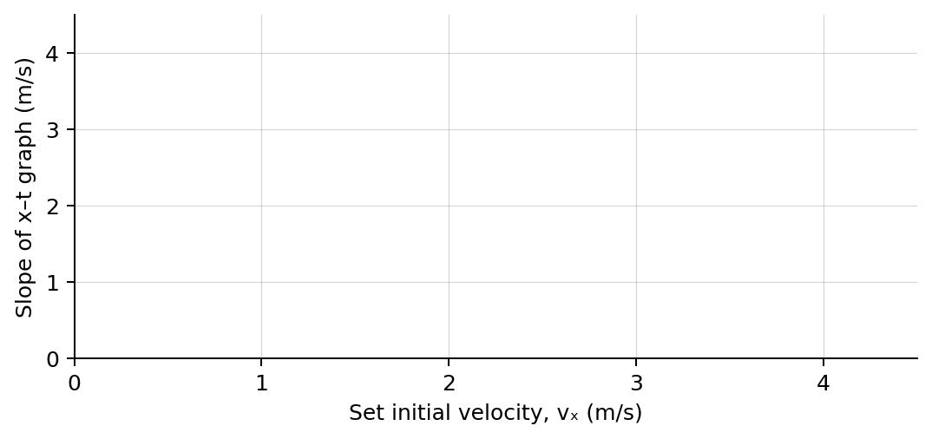
4. Plot graph slope versus the set initial velocity. Draw a best-fit line.

PART B Reverse direction and analyze
Direction test | 5 minutes
Set vₓ  (m/s) | x at 0 s  (m) | x at 2.0 s  (m) | Δx  (m) | x–t slope  (m/s) | aₓ  (m/s²)
−2.0
5. How did the sign of the slope identify the direction of motion?
______________________________________________________________________________________________
Analysis | 8 minutes
6. Compare each measured graph slope with the velocity you set. How close were they?
______________________________________________________________________________________________
7. What does the y-intercept of an x–t graph represent physically?
______________________________________________________________________________________________
8. Why can an object have nonzero velocity while its acceleration is zero?
______________________________________________________________________________________________
9. Predict the displacement of a block moving at −3.5 m/s for 4.0 s.
______________________________________________________________________________________________
Claim-Evidence-Reasoning conclusion
Evaluate this statement: “An object must have a net change in speed in order to change its position.”
CLAIM | Accept, reject, or revise the statement.
EVIDENCE | Cite at least two measurements or graph features.
REASONING | Connect your evidence to the kinematics model.
Exit ticket
A block’s x–t graph has a constant slope of +2.4 m/s. State its velocity and acceleration.
______________________________________________________________________________________________
______________________________________________________________________________________________

