BUILD PHYSICS | GUIDED INVESTIGATION
CRITICAL-ANGLE FRICTION
Using the onset of sliding to determine μₛ
Name: ____________________________ | Period: ____________ | Date: ______________

INVESTIGATION QUESTION What relationship connects the critical incline angle and the coefficient of static friction?
TIME  30 minutes | SIMULATION  BuildPhysics > Critical-angle friction | UNIT 2  Force & Translational Dynamics
Learning targets
• Locate the smallest incline angle that produces sustained sliding.
• Test whether the critical angle depends on block mass.
• Use the critical angle to determine a coefficient of static friction.
Model before you measure
At the threshold of motion, the downhill weight component equals maximum static friction. | mg sin θ = μ_{s}mg cos θ tan θ = μ_{s}
Important: Use g = 9.8 m/s². Near the threshold, change the ramp angle in increments of about 0.5° and reset before deciding whether motion is sustained.
Pre-lab prediction | 4 minutes
1. For μₛ = 0.50, estimate the critical angle before testing.
__________________________________________________________________________________________
2. Should doubling the block mass change the critical angle? Explain from the force equation.
__________________________________________________________________________________________
3. What force changes as the ramp angle increases even though the block's weight stays constant?
__________________________________________________________________________________________

PART A Test whether mass affects the critical angle
Setup | 3 minutes
□ Load Critical-angle friction. Keep μₛ = 0.50, μₖ = 0.35, and friction enabled.
□ Select the ramp and adjust its upper endpoint. Measure the angle in degrees.
□ For each mass, find the largest angle with no sustained slide and the smallest angle with sustained sliding.
□ Estimate the critical angle as the midpoint of those two measurements.
Sustained motion: A tiny settling motion does not count. The speed should continue increasing down the ramp after release.
Data table | 10 minutes
Mass  (kg) | Last no-slide angle  (deg) | First sliding angle  (deg) | Estimated critical angle  (deg) | tan θ
1.0
2.0
4.0
Force diagrams | 3 minutes
Just below critical angle | Just above critical angle
Draw and label F_{N}, mg, and static friction. | Draw and label F_{N}, mg, and kinetic friction.

PART B Change μₛ and test the model
Coefficient test | 7 minutes
Control: Keep mass at 2.0 kg. Change μₛ on both the block and ramp as needed, then locate the critical angle.
μₛ | Measured critical angle  (deg) | tan θ
0.30
0.50
0.70
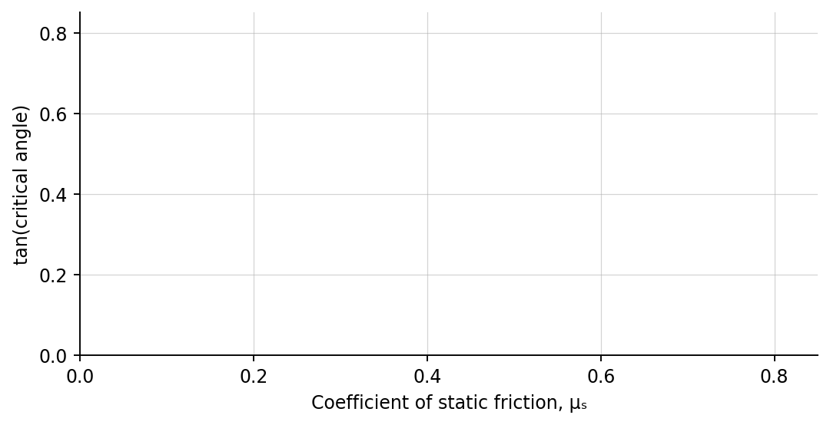
4. Plot tan θ versus μₛ. Draw the expected relationship.
Analysis | 6 minutes
5. Did mass affect the critical angle? Use evidence from Part A.
_______________________________________________________________________________________________
6. How closely did tan θ match μₛ?
_______________________________________________________________________________________________
7. Why does mass cancel from the critical-angle relationship?
_______________________________________________________________________________________________
Claim-Evidence-Reasoning conclusion
Evaluate this statement: “A heavier block begins sliding at a smaller incline angle than a lighter block with the same surfaces.”
CLAIM | Accept, reject, or revise the statement.
EVIDENCE | Cite at least two measurements or graph features.
REASONING | Connect your evidence to the force model and Newton's laws.
Exit ticket
Predict the critical angle for μₛ = 0.60. State the relationship you use.
____________________________________________________________________________________________
____________________________________________________________________________________________

