BUILD PHYSICS | GUIDED INVESTIGATION
ELLIPTICAL ORBIT
Radius, speed, gravitational force, energy, and angular momentum
Name: ____________________________ | Period: ____________ | Date: ______________

INVESTIGATION QUESTION How do orbital speed and gravitational force change between apoapsis and periapsis?
TIME  30 minutes | SIMULATION  BuildPhysics > Elliptical orbit | UNIT 6  Energy & Momentum of Rotating Systems
Learning targets
• Compare orbital quantities at apoapsis and periapsis.
• Test conservation of angular momentum in a central-force orbit.
• Track kinetic, gravitational potential, and total mechanical energy.
Model before you measure
Gravity is a central force, so its torque about the planet center is zero. The satellite moves fastest at periapsis and slowest at apoapsis. | L = mrv_{t} = constant E = ½mv² − GMm/r F_{g} = GMm/r²
Important: Use the planet center as the angular-momentum axis. Record radius from the planet center to the satellite center.
Pre-lab prediction | 4 minutes
1. At which point should speed be greatest: apoapsis or periapsis?
__________________________________________________________________________________________
2. At which point should gravitational-force magnitude be greatest?
__________________________________________________________________________________________
3. Predict how total mechanical energy changes during one complete orbit.
__________________________________________________________________________________________

PART A Analyze one complete elliptical orbit
Setup | 3 minutes
□ Load Elliptical orbit. Turn on the trail and graph radius, speed, gravitational force, kinetic energy, and gravitational potential energy.
□ Run at least one complete orbit and identify apoapsis and periapsis from the radius graph.
□ Pause at apoapsis and periapsis and record all requested quantities.
□ Calculate mrv at each point using the tangential speed.
Apoapsis-periapsis data | 10 minutes
Location | Radius r  (m) | Speed v  (m/s) | |Fg|  (N) | K  (J) | Ug  (J) | Angular momentum mrv  (kg·m²/s)
Apoapsis
Periapsis
Energy comparison | 3 minutes
Total mechanical energy at apoapsis  (J) | Total mechanical energy at periapsis  (J) | Orbital period  (s)

PART B Change the initial tangential speed
Orbit-shape test | 8 minutes
Procedure: Reset to the same starting radius. Change only the initial tangential speed, run one orbit, and record the new apoapsis and periapsis values.
Trial | Initial speed  (m/s) | ra / rp | vp / va | Total mechanical energy  (J) | Orbit classification
Trial 1
Trial 2
Trial 3
Trial 4
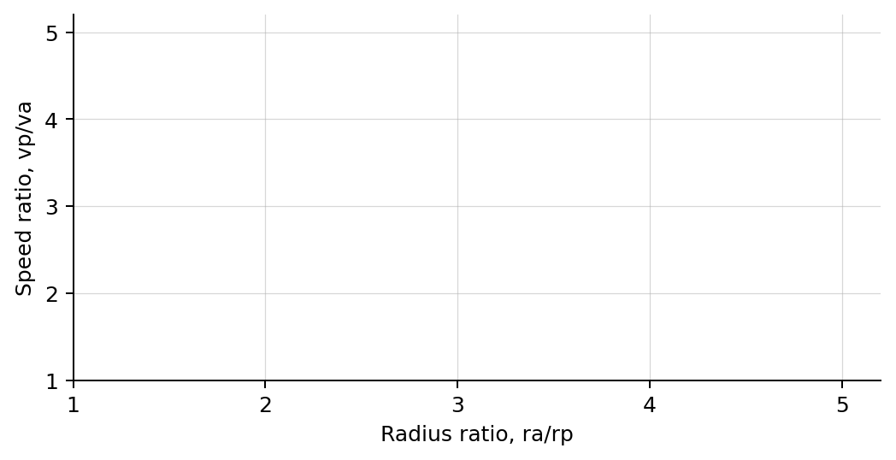
4. Plot speed ratio vp/va versus radius ratio ra/rp. Draw a best-fit line.
Analysis | 6 minutes
5. Compare angular momentum at apoapsis and periapsis.
_______________________________________________________________________________________________
6. How did kinetic and gravitational potential energy trade off during the orbit?
_______________________________________________________________________________________________
7. Why should vp/va equal ra/rp at the two apsides?
_______________________________________________________________________________________________
8. How did changing initial speed affect orbit shape and total mechanical energy?
_______________________________________________________________________________________________
Claim-Evidence-Reasoning conclusion
Evaluate this claim: The satellite moves faster at periapsis because gravity does more positive work there than at other parts of the orbit.
CLAIM | Accept, reject, or revise the statement.
EVIDENCE | Cite at least two measured trials or graph features.
REASONING | Use central-force torque, angular momentum conservation, and energy changes over the full path.
Exit ticket
At apoapsis the orbital radius is three times the periapsis radius. Use angular momentum conservation to predict vp/va.
_______________________________________________________________________________________________
_______________________________________________________________________________________________

