BUILD PHYSICS | GUIDED INVESTIGATION
INCLINED PLANE
Ramp angle, force components, and acceleration
Name: ____________________________ | Period: ____________ | Date: ______________

INVESTIGATION QUESTION How does ramp angle affect the acceleration of a block on a frictionless incline?
TIME  30 minutes | SIMULATION  BuildPhysics > Inclined plane | UNIT 2  Force & Translational Dynamics
Learning targets
• Resolve weight into components parallel and perpendicular to a ramp.
• Test the relationship between acceleration and sin θ.
• Determine whether mass affects frictionless incline acceleration.
Model before you measure
Keep friction off. Choose the positive direction down the ramp. Use the angle tool or the displayed surface angle to set each trial. | F∥ = mg sin θ F_{N} = mg cos θ a = g sin θ
Important: Use g = 9.8 m/s² for calculations. Reset after changing the ramp geometry so the block begins from rest on the surface.
Pre-lab prediction | 4 minutes
1. As the ramp becomes steeper, what should happen to the component of weight parallel to the ramp?
__________________________________________________________________________________________
2. Predict the acceleration at θ = 30°.
__________________________________________________________________________________________
3. Will a 4 kg block accelerate faster than a 1 kg block on the same frictionless ramp? Explain.
__________________________________________________________________________________________

PART A Change ramp angle and measure acceleration
Setup | 3 minutes
□ Load Inclined plane. Confirm friction is off and parallel/perpendicular force components are visible.
□ Select the incline and adjust its upper endpoint until the angle matches the table.
□ Select the block and display acceleration and force values. Keep mass constant.
□ Reset, run for about 1 s, pause, and record the acceleration along the ramp.
Angle sequence: Use 10°, 20°, 30°, 40°, and 50°. Place the block at the same relative position before each trial.
Data table | 10 minutes
θ  (deg) | sin θ | Predicted a = g sin θ  (m/s²) | Measured a  (m/s²) | Measured Fₙ  (N)
10
20
30
40
50
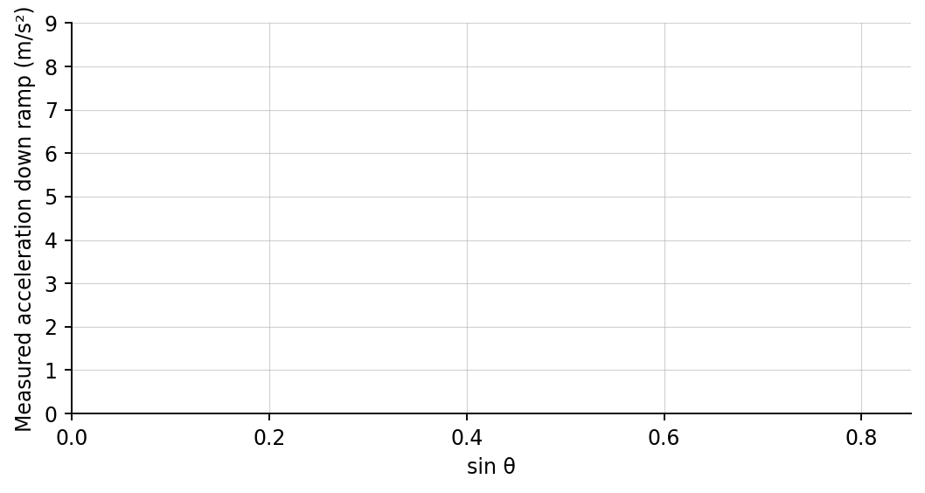
4. Plot measured acceleration versus sin θ. Draw a best-fit line.

PART B Change mass at a fixed angle
Mass test | 6 minutes
Fixed geometry: Set θ = 30°. Use the same starting position and keep friction off.
Mass  (kg) | Measured a  (m/s²) | Parallel weight component  (N) | Normal force  (N)
1.0
2.0
4.0
Analysis | 8 minutes
5. What did the slope of the acceleration-versus-sin θ graph represent? Compare it with 9.8 m/s².
_______________________________________________________________________________________________
6. How did the normal force change as angle increased? Explain using components.
_______________________________________________________________________________________________
7. How did mass affect acceleration at 30°? How did it affect the force components?
_______________________________________________________________________________________________
8. Why does mass cancel when deriving a = g sin θ?
_______________________________________________________________________________________________
Claim-Evidence-Reasoning conclusion
Evaluate this statement: “A heavier block slides faster than a lighter block on the same frictionless incline.”
CLAIM | Accept, reject, or revise the statement.
EVIDENCE | Cite at least two measurements or graph features.
REASONING | Connect your evidence to the force model and Newton's laws.
Exit ticket
At what incline angle would a frictionless block accelerate at 4.9 m/s²? Show the relationship you use.
____________________________________________________________________________________________
____________________________________________________________________________________________

