BUILD PHYSICS | GUIDED INVESTIGATION
MASS-SPRING OSCILLATOR
Period, force, phase relationships, and energy exchange
Name: ____________________________ | Period: ____________ | Date: ______________

INVESTIGATION QUESTION How do mass, spring constant, and amplitude affect simple harmonic motion?
TIME  30 minutes | SIMULATION  BuildPhysics > Mass-spring oscillator | UNIT 7  Oscillations
Learning targets
• Test how oscillator mass affects the period.
• Connect spring force and acceleration to displacement.
• Compare kinetic and spring potential energy during a cycle.
Model before you measure
The preset uses a horizontal spring with gravity turned off. Displacement x is measured from equilibrium. | F_{s} = −kx a = −(k/m)x T = 2π√(m/k)
Important: The baseline preset uses m = 1.0 kg and k = 8.0 N/m. Reset before every trial and time several complete cycles.
Pre-lab prediction | 4 minutes
1. If oscillator mass quadruples, by what factor should the period change?
__________________________________________________________________________________________
2. At maximum displacement, predict the velocity, acceleration magnitude, and spring energy.
__________________________________________________________________________________________
3. Predict whether changing amplitude changes the ideal period.
__________________________________________________________________________________________

PART A Change oscillator mass
Setup | 3 minutes
□ Load Mass-spring oscillator. Confirm gravity is off and record the spring constant k.
□ Use the same initial extension from equilibrium in every Part A trial.
□ Set each listed mass, reset, and run five complete cycles.
□ Record total time, calculate T and T², and observe the x, vₓ, and aₓ graphs.
Consistent amplitude: After changing mass, return the oscillator to the same starting displacement before resetting and running.
Data table | 10 minutes
Mass m  (kg) | Time for 5 cycles  (s) | Measured T  (s) | T²  (s²) | Predicted T  (s) | Maximum speed  (m/s)
0.50
1.00
1.50
2.00
2.50
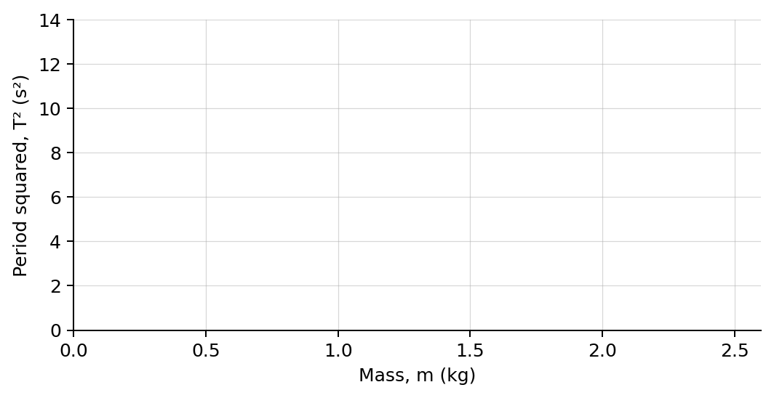
4. Plot T² versus mass. Draw a best-fit line.

PART B Change starting amplitude
Amplitude and energy test | 7 minutes
Fixed inputs: Use m = 1.0 kg and k = 8.0 N/m. Change only the initial displacement magnitude A.
Amplitude A  (m) | Measured period T  (s) | Maximum speed  (m/s) | Maximum spring energy  (J) | Maximum kinetic energy  (J)
0.50
0.75
1.00
1.25
Analysis | 7 minutes
5. What should the slope of the T²-versus-m graph equal? Compare with 4π²/k.
_______________________________________________________________________________________________
6. How did increasing mass affect period and maximum speed at fixed amplitude?
_______________________________________________________________________________________________
7. How did changing amplitude affect period, maximum speed, and total energy?
_______________________________________________________________________________________________
8. Describe the phase relationships among x, vₓ, aₓ, spring force, kinetic energy, and spring energy.
_______________________________________________________________________________________________
_______________________________________________________________________________________________
Claim-Evidence-Reasoning conclusion
Evaluate this claim: At equilibrium, the oscillator has zero net force because its speed is greatest.
CLAIM | Accept, reject, or revise the statement.
EVIDENCE | Cite at least two measured trials or graph features.
REASONING | Use the force, acceleration, velocity, and energy graphs at equilibrium and turning points.
Exit ticket
A spring constant is increased from k to 4k while mass stays fixed. Predict the new period relative to the original.
_______________________________________________________________________________________________
_______________________________________________________________________________________________

