BUILD PHYSICS | GUIDED INVESTIGATION
MODIFIED ATWOOD MACHINE
A hanging mass pulling a block across a table
Name: ____________________________ | Period: ____________ | Date: ______________

INVESTIGATION QUESTION How does each mass affect the acceleration of a modified Atwood system?
TIME  30 minutes | SIMULATION  BuildPhysics > Modified Atwood machine | UNIT 2  Force & Translational Dynamics
Learning targets
• Write a system equation for a hanging mass connected to a table mass.
• Test how the hanging and table masses affect acceleration differently.
• Compare ideal and frictional models.
Model before you measure
Keep the table frictionless for Parts A and B. Let mₕ be the hanging mass and mₜ be the table mass. | a = m_{h}g/(m_{h} + m_{t}) T = m_{t}a
Important: Use g = 9.8 m/s². The weight of the hanging mass is the external driving force on the two-block system.
Pre-lab prediction | 4 minutes
1. What should happen to acceleration when the hanging mass increases?
__________________________________________________________________________________________
2. What should happen when the table mass increases but the hanging mass stays fixed?
__________________________________________________________________________________________
3. Is rope tension equal to the hanging mass's weight while the system accelerates? Explain.
__________________________________________________________________________________________

PART A Change the hanging mass
Setup | 3 minutes
□ Load Modified Atwood machine. Confirm the table is frictionless and the pulley is massless.
□ Keep the table mass at 1.0 kg. Change only the hanging mass.
□ Display acceleration and tension values. Reset before every run.
□ Run briefly and pause before the hanging mass reaches the bottom.
Data table | 10 minutes
mₕ  (kg) | mₕ/(mₕ+mₜ) | Predicted a  (m/s²) | Measured a  (m/s²) | Measured T  (N)
0.50
1.00
1.50
2.00
3.00
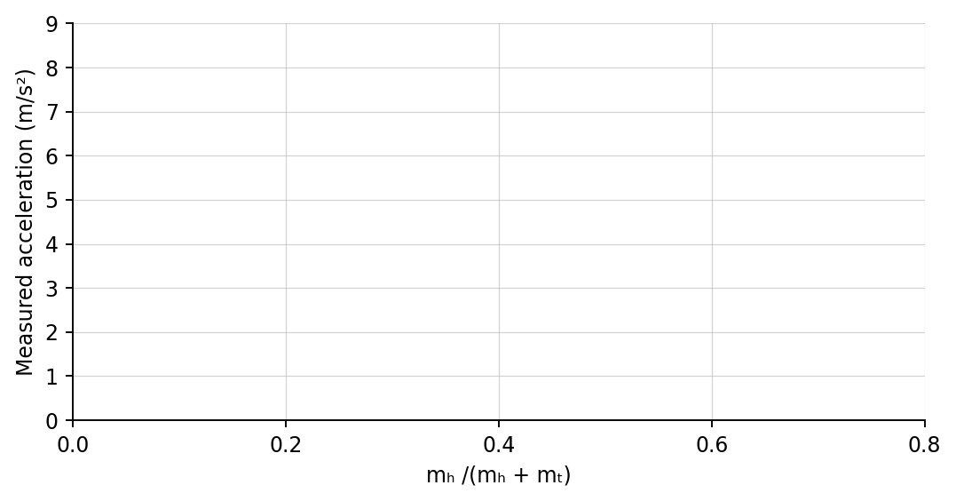
4. Plot measured acceleration versus mₕ/(mₕ + mₜ). Draw a best-fit line.

PART B Change the table mass and test friction
Table-mass test | 6 minutes
Constant input: Keep mₕ = 2.0 kg. Change only mₜ.
mₜ  (kg) | Predicted a  (m/s²) | Measured a  (m/s²)
0.50
1.00
2.00
3.00
Friction challenge | 3 minutes
Return to mₕ = 2.0 kg and mₜ = 1.0 kg. Turn friction on, run one trial, and record the new acceleration: __________________ m/s².
Analysis | 6 minutes
5. What did the slope of the Part A graph represent?
_______________________________________________________________________________________________
6. Why did adding table mass reduce acceleration even though the hanging weight stayed constant?
_______________________________________________________________________________________________
7. Compare tension with mₕg. Why are they not equal during acceleration?
_______________________________________________________________________________________________
8. How did friction change the system net force and acceleration?
_______________________________________________________________________________________________
Claim-Evidence-Reasoning conclusion
Evaluate this statement: “Increasing the table mass cannot change acceleration because the hanging force is unchanged.”
CLAIM | Accept, reject, or revise the statement.
EVIDENCE | Cite at least two measurements or graph features.
REASONING | Connect your evidence to the force model and Newton's laws.
Exit ticket
Find the ideal acceleration when mₕ = 1.5 kg and mₜ = 2.5 kg. Use g = 9.8 m/s².
____________________________________________________________________________________________
____________________________________________________________________________________________

