BUILD PHYSICS | GUIDED INVESTIGATION
NET FORCE AND ACCELERATION
Vector addition, acceleration, and the direction of ΣF
Name: ____________________________ | Period: ____________ | Date: ______________

INVESTIGATION QUESTION How do multiple forces combine to determine an object's acceleration?
TIME  30 minutes | SIMULATION  BuildPhysics > Net force and acceleration | UNIT 2  Force & Translational Dynamics
Learning targets
• Add force components vectorially and compare the result with the displayed net force.
• Test whether acceleration is parallel to the net-force vector.
• Explain how mass changes acceleration without changing the applied-force sum.
Model before you measure
The preset is gravity-free. Choose +x right and +y up. Use the Object Inspector to set exact x- and y-components for each applied force. | ΣF = ma
Important: The acceleration vector follows the net force, not necessarily any single applied force. Use g = 9.8 m/s² only if you later turn gravity on.
Pre-lab prediction | 4 minutes
1. Two forces are 6 N east and 8 N north. Predict the magnitude and direction of their vector sum.
__________________________________________________________________________________________
2. What should happen to acceleration when the applied forces add to zero?
__________________________________________________________________________________________
3. If the same net force acts on twice the mass, how should acceleration change?
__________________________________________________________________________________________

PART A Add forces and test vector addition
Setup | 3 minutes
□ Load Net force and acceleration. Confirm gravity is off and the Force disk is selected.
□ Use Draw force to add two forces. In the Object Inspector, edit each force component to match the table.
□ Keep mass at 1.00 kg. Turn on ΣF, acceleration, vector values, and x- and y-components.
□ Reset after every change, run briefly, pause, and record the displayed acceleration.
Consistent trials: Change only the listed force components. The disk may move off-screen during a long run, so pause after about 0.5 s.
Data table | 10 minutes
Trial | F₁x  (N) | F₁y  (N) | F₂x  (N) | F₂y  (N) | Predicted |ΣF|  (N) | Measured |a|  (m/s²) | Direction of a
1 | +6 | 0 | 0 | +8
2 | +10 | 0 | −4 | 0
3 | +6 | +8 | −6 | 0
4 | +5 | +5 | −2 | −9
5 | +8 | 0 | −8 | 0
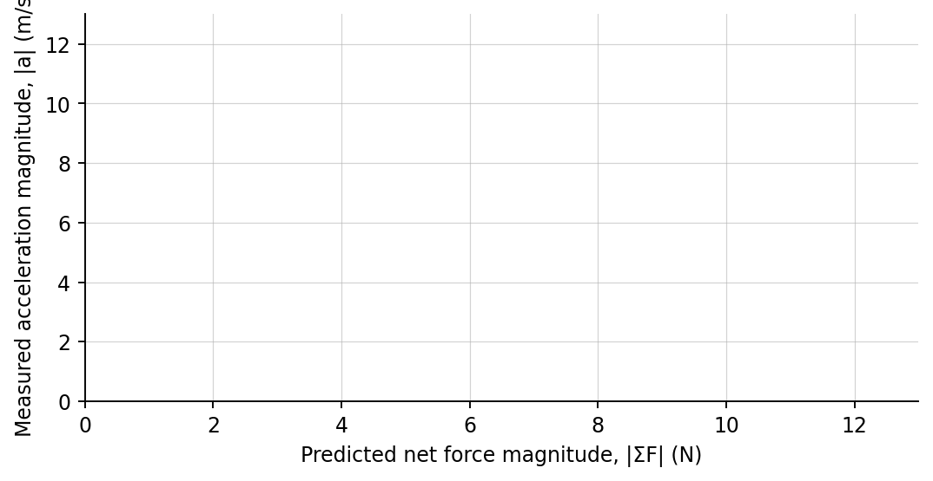
4. Plot measured |a| versus predicted |ΣF|. Draw a best-fit line.

PART B Keep the force sum constant and change mass
Mass test | 7 minutes
Force pair: Use F₁ = 6 N east and F₂ = 8 N north for every trial. The net-force magnitude is 10 N.
Mass m  (kg) | Predicted |a| = |ΣF|/m  (m/s²) | Measured |a|  (m/s²)
0.50
1.00
2.00
4.00
Analysis | 7 minutes
5. For which trial in Part A was the acceleration zero? Explain using vector addition.
_______________________________________________________________________________________________
6. Compare the direction of a with the direction of ΣF in at least two trials.
_______________________________________________________________________________________________
7. How did changing mass affect acceleration when the force sum stayed constant?
_______________________________________________________________________________________________
8. Why is it incorrect to predict acceleration from only the largest individual force?
_______________________________________________________________________________________________
Claim-Evidence-Reasoning conclusion
Evaluate this statement: “The largest individual force always determines the direction of acceleration.”
CLAIM | Accept, reject, or revise the statement.
EVIDENCE | Cite at least two measurements or graph features.
REASONING | Connect your evidence to the force model and Newton's laws.
Exit ticket
A 2.0 kg object experiences 3.0 N east and 4.0 N north. Determine the magnitude and direction of its acceleration.
____________________________________________________________________________________________
____________________________________________________________________________________________

