BUILD PHYSICS
Newton's Second Law
BuildPhysics Guided Investigation
Name: ____________________________ | Period: _______________ | Date: _______________
Investigation question: How do net force and mass determine an object's acceleration?  Learning goals: Collect controlled data, identify direct and inverse relationships, and use graph slopes to interpret Newton's second law. | 30 minutes  4 min setup  9 min Part A  9 min Part B  8 min analysis
1. Open and verify the preset
☐ Open BuildPhysics and load Unit 2 -> Newton's Second Law.
☐ Select the block. Confirm the starting mass is 2.0 kg and the horizontal applied force is 6.0 N.
☐ Keep friction off. Keep the block on the horizontal surface and begin each trial from rest.
☐ Open Analyze -> Graph. Display net force x, acceleration x, and velocity x.
☐ For every trial: change only the listed variable, press Reset, run briefly, pause, and record the constant acceleration.
Measurement tip: Use the flat value on the acceleration graph or the selected-object acceleration readout. Record at least two significant figures.
2. Predict before collecting data
1. If the net force doubles while mass remains constant, what should happen to acceleration? Explain.
________________________________________________________________________________
2. If the mass doubles while net force remains constant, what should happen to acceleration? Explain.
________________________________________________________________________________
3. Identify the independent variable, dependent variable, and two controlled variables for Part A.
________________________________________________________________________________

Part A - How does acceleration depend on net force?
Keep mass constant at 2.0 kg. Change only the horizontal applied force. Reset before each trial.
Trial | Mass  m (kg) | Net force  Fnet,x (N) | Predicted a  Fnet/m (m/s²) | Measured ax  (m/s²)
1 | 2.0 | 3.0
2 | 2.0 | 6.0
3 | 2.0 | 9.0
4 | 2.0 | 12.0
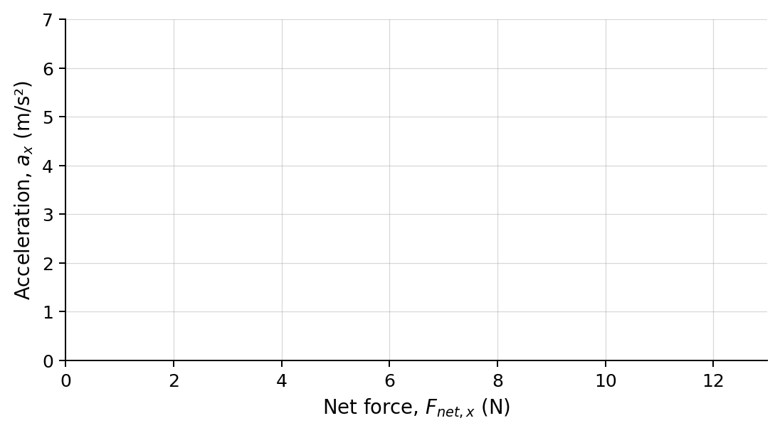
4. Plot measured acceleration versus net force. Draw a best-fit line.
5. Calculate the slope of your best-fit line, including units.
________________________________________________________________________________
6. What physical quantity does the slope represent? Compare it with the value expected from the constant mass.
________________________________________________________________________________
________________________________________________________________________________

Part B - How does acceleration depend on mass?
Keep net force constant at 6.0 N. Change only the block's mass. Reset before each trial.
Trial | Net force  Fnet,x (N) | Mass  m (kg) | 1/m  (1/kg) | Predicted a  Fnet/m (m/s²) | Measured ax  (m/s²)
1 | 6.0 | 1.0
2 | 6.0 | 2.0
3 | 6.0 | 3.0
4 | 6.0 | 4.0
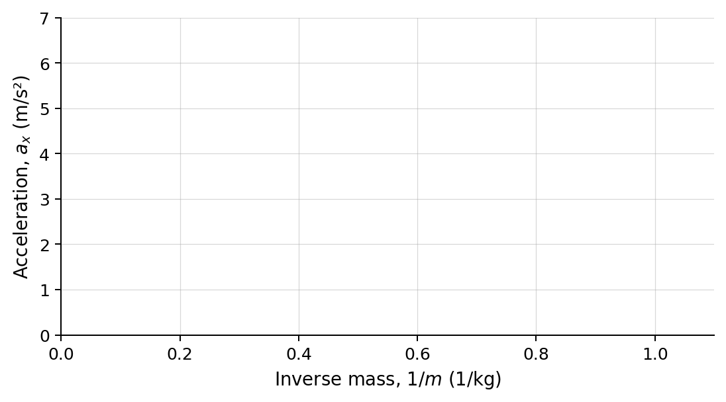
7. Plot measured acceleration versus 1/m. Draw a best-fit line.
8. Calculate the slope of this graph, including units.
________________________________________________________________________________
9. What physical quantity does the slope represent? Compare it with the constant force used in Part B.
________________________________________________________________________________
________________________________________________________________________________

3. Analysis and conclusion
10. State the mathematical relationship between acceleration and net force when mass is constant.
________________________________________________________________________________
11. State the mathematical relationship between acceleration and mass when net force is constant.
________________________________________________________________________________
12. Why is acceleration versus mass curved, while acceleration versus 1/m is linear?
________________________________________________________________________________
________________________________________________________________________________
13. A 5.0 kg block experiences a net force of 15 N. Predict its acceleration. Then test your prediction in BuildPhysics and record the measured value.
________________________________________________________________________________
________________________________________________________________________________
Claim | Write one sentence that answers the investigation question.
Evidence | Use at least two numerical results or graph slopes.
Reasoning | Connect your evidence to Fnet = ma and the patterns in both investigations.
One source of uncertainty | Describe one measurement or setup choice that could affect your results.
4. Exit ticket
14. Without running another trial, predict the acceleration of a 2.5 kg block under a 10 N net force. Show your reasoning.
________________________________________________________________________________
________________________________________________________________________________
Confidence: 1 2 3 4 5 (circle one)

