BUILD PHYSICS | GUIDED INVESTIGATION
ONE-DIMENSIONAL COLLISION
Momentum conservation, kinetic energy, and restitution
Name: ____________________________ | Period: ____________ | Date: ______________

INVESTIGATION QUESTION What is conserved in a collision, and how does restitution affect the outcome?
TIME  30 minutes | SIMULATION  BuildPhysics > One-dimensional collision | UNIT 4  Linear Momentum
Learning targets
• Compare total momentum before and after collisions.
• Distinguish elastic, partially inelastic, and perfectly inelastic collisions.
• Use restitution and kinetic-energy data to characterize a collision.
Model before you measure
Treat both carts as one system during the brief collision. External horizontal impulse is negligible. | p_{total,i} = p_{total,f} e = (v_{2f} − v_{1f})/(v_{1i} − v_{2i})
Important: Momentum should be tested for the two-cart system. Kinetic energy is conserved only in an elastic collision.
Pre-lab prediction | 4 minutes
1. Predict what happens to total momentum as restitution changes from 0 to 1.
__________________________________________________________________________________________
2. Predict what happens to total kinetic energy as restitution increases.
__________________________________________________________________________________________
3. For equal masses with cart 2 initially at rest, predict the elastic-collision velocities.
__________________________________________________________________________________________

PART A Change restitution
Setup | 3 minutes
□ Load One-dimensional collision. Keep friction off.
□ Record both masses and initial velocities. Keep them fixed for all Part A trials.
□ Turn on Energy and momentum totals. Graph pₓ and velocity for each cart.
□ Set both carts to the listed restitution, reset, run through one collision, and pause after separation.
System data: Record total pₓ and total kinetic energy immediately before and immediately after the collision.
Data table | 10 minutes
Restitution e | Total pₓ before  (kg·m/s) | Total pₓ after  (kg·m/s) | K before  (J) | K after  (J) | K after / K before
0.00
0.25
0.50
0.75
1.00
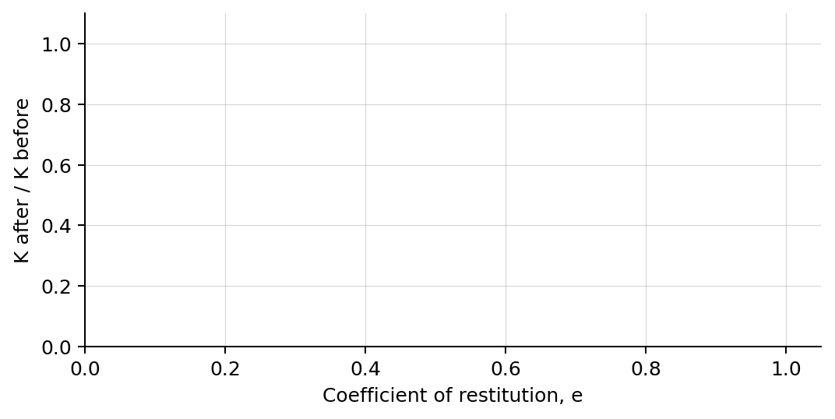
4. Plot K after / K before versus restitution. Draw a smooth trend.

PART B Change the mass ratio
Mass-ratio test | 7 minutes
Controlled inputs: Use e = 1.00. Keep cart 1's mass and initial velocity fixed. Keep cart 2 initially at rest.
Cart 2 mass  (kg) | Cart 1 final vₓ  (m/s) | Cart 2 final vₓ  (m/s)
0.50
1.00
2.00
4.00
Analysis | 7 minutes
5. How closely was total momentum conserved in all Part A trials?
_______________________________________________________________________________________________
6. How did restitution affect kinetic energy retained by the two-cart system?
_______________________________________________________________________________________________
7. How did increasing cart 2's mass change the two final velocities?
_______________________________________________________________________________________________
8. Explain why momentum can be conserved even when kinetic energy is not.
_______________________________________________________________________________________________
Claim-Evidence-Reasoning conclusion
Evaluate this claim: A collision with conserved momentum must also conserve kinetic energy.
CLAIM | Accept, reject, or revise the statement.
EVIDENCE | Cite at least two measured trials or graph features.
REASONING | Connect your evidence to system momentum, restitution, and energy transformation.
Exit ticket
Two carts stick together after colliding. Name the conserved quantity and write the equation used to find their shared final velocity.
_______________________________________________________________________________________________
_______________________________________________________________________________________________

