BUILD PHYSICS | GUIDED INVESTIGATION
PERIOD OF A PENDULUM
Length, mass, amplitude, and small-angle oscillations
Name: ____________________________ | Period: ____________ | Date: ______________

INVESTIGATION QUESTION How does pendulum length affect its period, and does the bob's mass matter?
TIME  30 minutes | SIMULATION  BuildPhysics > Period of a pendulum | UNIT 7  Oscillations
Learning targets
• Measure a pendulum's period from multiple complete cycles.
• Test the predicted relationship between period and pendulum length.
• Determine whether bob mass changes the period.
Model before you measure
The preset begins with a 1.0 kg bob released from a small angle. Measure length from the pivot to the bob's center. | T = 2π√(L/g) T² = (4π²/g)L
Important: Use g = 9.8 m/s². Time five complete cycles and divide by five to reduce timing uncertainty.
Pre-lab prediction | 4 minutes
1. If pendulum length is quadrupled, by what factor should the period change?
__________________________________________________________________________________________
2. Predict whether doubling the bob's mass changes the period.
__________________________________________________________________________________________
3. At which location are speed and kinetic energy greatest?
__________________________________________________________________________________________

PART A Change pendulum length
Setup | 3 minutes
□ Load Period of a pendulum. Confirm the release angle is about 15° and the bob begins from rest.
□ Set each pivot-to-center length listed below by adjusting the string length.
□ Keep bob mass and release angle constant.
□ Reset, run five complete cycles, record the total time, and calculate the period T.
Cycle definition: One complete cycle returns the bob to the same side with the same direction of motion.
Data table | 10 minutes
Length L  (m) | √L  (√m) | Time for 5 cycles  (s) | Measured period T  (s) | Predicted T  (s) | T²  (s²)
1.0
2.0
3.0
4.0
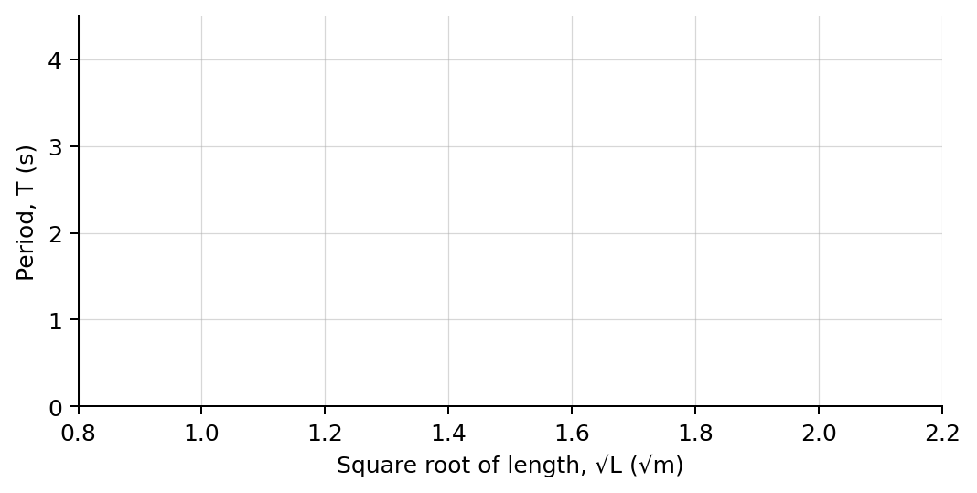
4. Plot measured period T versus √L. Draw a best-fit line.

PART B Change bob mass
Mass test | 7 minutes
Fixed inputs: Use L = 3.0 m and the same small release angle for every mass trial.
Bob mass  (kg) | Time for 5 cycles  (s) | Measured period T  (s)
0.50
1.00
2.00
3.00
Analysis | 7 minutes
5. What relationship did the T-versus-√L graph show?
_______________________________________________________________________________________________
6. What should the slope of the graph equal? Use g = 9.8 m/s² to calculate the expected value.
_______________________________________________________________________________________________
7. How did changing bob mass affect the period?
_______________________________________________________________________________________________
8. Explain why the bob's speed is greatest at equilibrium and zero at each turning point.
_______________________________________________________________________________________________
Claim-Evidence-Reasoning conclusion
Evaluate this claim: A heavier pendulum bob swings with a longer period because gravity exerts a larger force.
CLAIM | Accept, reject, or revise the statement.
EVIDENCE | Cite at least two measured trials or graph features.
REASONING | Use the measured mass trials and the period equation to distinguish force magnitude from acceleration.
Exit ticket
A pendulum's length is increased from L to 9L. Predict its new period relative to the original period.
_______________________________________________________________________________________________
_______________________________________________________________________________________________

