BUILD PHYSICS | GUIDED INVESTIGATION
PROJECTILE-MOTION INDEPENDENCE
Comparing dropped and horizontally launched objects
Name: ____________________________ | Period: __________ | Date: ____________

INVESTIGATION QUESTION Does horizontal velocity change the time required to fall from a given height?
TIME  30 minutes | SIMULATION  BuildPhysics > Projectile-motion independence | UNIT 1  Kinematics
Learning targets
• Compare the vertical position and velocity of two objects with different horizontal velocities.
• Test whether horizontal launch speed affects fall time.
• Relate horizontal range to horizontal speed and common flight time.
Model before you measure
Both objects begin at the same height with vᵧ₀ = 0.  One object is dropped; the other has a horizontal velocity. | Vertical model for both objects  Δy = −½gt²  vᵧ = −gt  g = 9.8 m/s²
Key comparison: At the same time, compare y, vᵧ, and aᵧ—not the total speed or horizontal position.
Pre-lab prediction | 4 minutes
1. Which ball should reach the ground first? Explain your reasoning.
______________________________________________________________________________________________
2. At t = 1.0 s, predict whether the balls have the same y and vᵧ.
______________________________________________________________________________________________
3. What should happen to the launched ball’s range if vₓ doubles?
______________________________________________________________________________________________

PART A Compare vertical motion
Setup | 3 minutes
□ Load Projectile-motion independence. Keep the dropped ball at vₓ = 0 and the launched ball at vₓ = 6.0 m/s.
□ Open graph data. For each ball, display y and vᵧ.
□ Reset and run both objects together. Pause at each listed time and record the values.
□ Continue until both objects first contact the landing ground.
Synchronized data | 8 minutes
t  (s) | Dropped y  (m) | Launched y  (m) | Dropped vᵧ  (m/s) | Launched vᵧ  (m/s)
0.25
0.50
0.75
1.00
Object | Initial vₓ  (m/s) | Landing time  (s) | Horizontal range  (m) | vᵧ before landing  (m/s)
Dropped ball | 0.0
Launched ball | 6.0
4. Use your measurements to state whether the vertical motions matched.
______________________________________________________________________________________________
______________________________________________________________________________________________

PART B Change horizontal speed
Controlled trials | 8 minutes
Keep the starting height and vᵧ₀ = 0 unchanged. Change only the launched ball’s vₓ.
Trial | Launched vₓ  (m/s) | Dropped landing  time (s) | Launched landing  time (s) | Launched range  (m)
1 | 3.0
2 | 6.0
3 | 9.0
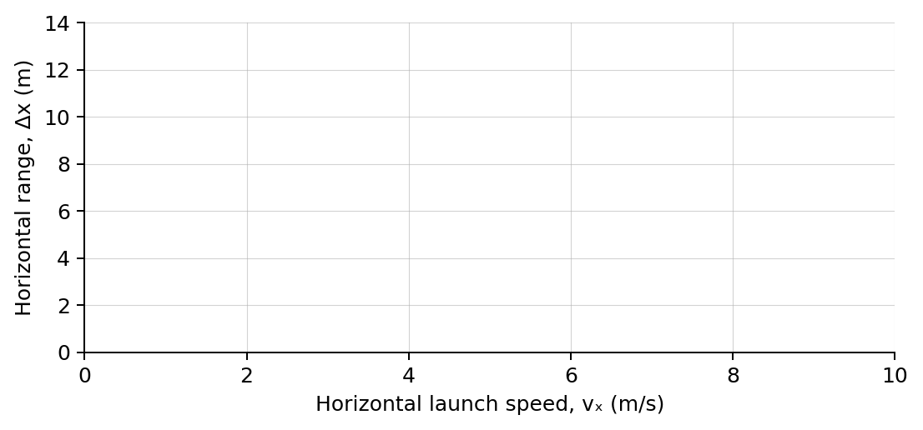
5. Plot range versus vₓ. What does the slope represent physically?
______________________________________________________________________________________________
Analysis | 6 minutes
6. Why does changing vₓ change range but not landing time?
______________________________________________________________________________________________
7. How can two objects have the same vᵧ but different total speeds?
______________________________________________________________________________________________
8. Use Δy = −½gt² and g = 9.8 m/s² to explain why both objects have the same fall time.
______________________________________________________________________________________________
Claim-Evidence-Reasoning conclusion
Evaluate this statement: “A horizontally launched object stays in the air longer than an object dropped from the same height.”
CLAIM | Accept, reject, or revise the statement.
EVIDENCE | Cite at least two measurements or graph features.
REASONING | Connect your evidence to the kinematics model.
Exit ticket
Two balls leave the same height with identical vᵧ₀ but different vₓ. Which vertical quantities must be identical at every shared time?
______________________________________________________________________________________________
______________________________________________________________________________________________

