BUILD PHYSICS | GUIDED INVESTIGATION
PROJECTILE MOTION
Independent horizontal and vertical motion
Name: ____________________________ | Period: __________ | Date: ____________

INVESTIGATION QUESTION How do the horizontal and vertical launch components affect a projectile’s trajectory?
TIME  30 minutes | SIMULATION  BuildPhysics > Projectile motion | UNIT 1  Kinematics
Learning targets
• Separate projectile motion into horizontal and vertical components.
• Determine how vₓ affects range and how vᵧ₀ affects flight time and maximum height.
• Use g = 9.8 m/s² to connect measured motion with kinematic predictions.
Model before you measure
Ignore air resistance.  Horizontal acceleration is zero; vertical acceleration is constant and downward. | Projectile model  x = x₀ + vₓt  y = y₀ + vᵧ₀t − ½gt²  vᵧ = vᵧ₀ − gt
Use throughout: g = 9.8 m/s² downward. The launch and landing surfaces are at the same height in this preset.
Pre-lab prediction | 4 minutes
1. If vₓ increases while vᵧ₀ stays constant, predict the changes in flight time, maximum height, and range.
______________________________________________________________________________________________
______________________________________________________________________________________________
2. If vᵧ₀ increases while vₓ stays constant, predict the same three quantities.
______________________________________________________________________________________________
______________________________________________________________________________________________

PART A Change horizontal velocity
Setup | 3 minutes
□ Load Projectile motion. Select the Projectile.
□ Turn on trail, vector values, vector components, and graph data.
□ Keep vᵧ₀ = +6.0 m/s. Change only vₓ using the object velocity controls.
□ Reset before each trial. Run until the projectile first returns to the ground.
Data table | 8 minutes
Trial | vₓ  (m/s) | vᵧ₀  (m/s) | Flight time  (s) | Maximum y  (m) | Range Δx  (m) | vₓ before  landing
1 | 4.0 | 6.0
2 | 7.0 | 6.0
3 | 10.0 | 6.0
3. Which measured quantities stayed nearly unchanged as vₓ changed?
______________________________________________________________________________________________
4. Describe the relationship between vₓ and horizontal range.
______________________________________________________________________________________________
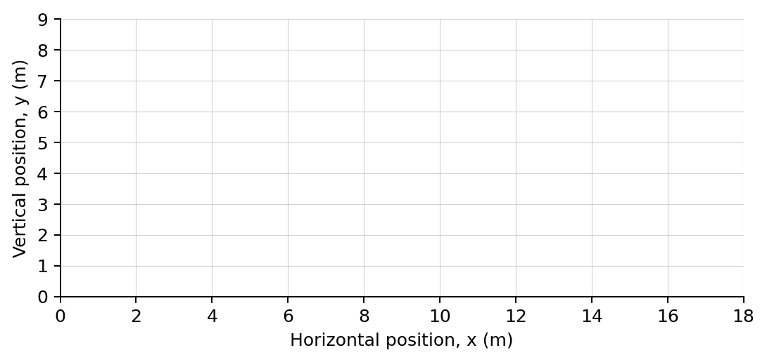
Sketch the three trajectories on the same axes and label each vₓ.

PART B Change vertical velocity and analyze
Controlled trials | 8 minutes
Keep vₓ = +7.0 m/s. Change only vᵧ₀.
Trial | vₓ  (m/s) | vᵧ₀  (m/s) | Flight time  (s) | Maximum y  (m) | Range Δx  (m) | vᵧ just before  landing
1 | 7.0 | 3.0
2 | 7.0 | 6.0
3 | 7.0 | 9.0
Analysis | 7 minutes
5. How did increasing vᵧ₀ affect flight time and maximum height?
______________________________________________________________________________________________
6. Why did vₓ remain nearly constant throughout each flight?
______________________________________________________________________________________________
7. For a same-height landing, compare the magnitude of vᵧ just before landing with vᵧ₀.
______________________________________________________________________________________________
8. Use g = 9.8 m/s² to predict the flight time for vᵧ₀ = 8.0 m/s. Then predict the range if vₓ = 5.0 m/s.
______________________________________________________________________________________________
______________________________________________________________________________________________
Claim-Evidence-Reasoning conclusion
Evaluate this statement: “The horizontal velocity of a projectile changes because gravity pulls the projectile downward.”
CLAIM | Accept, reject, or revise the statement.
EVIDENCE | Cite at least two measurements or graph features.
REASONING | Connect your evidence to the kinematics model.
Exit ticket
A projectile has vₓ = 6.0 m/s and vᵧ₀ = 4.0 m/s. State aₓ and aᵧ during flight.
______________________________________________________________________________________________
______________________________________________________________________________________________

