BUILD PHYSICS | GUIDED INVESTIGATION
RAMP, ELASTIC COLLISION & PROJECTILE MOTION
Energy, elastic collision equations, rebound, and horizontal launch
Name: ____________________________ | Period: ____________ | Date: ______________

INVESTIGATION QUESTION How can one continuous event be analyzed using energy, momentum, and projectile motion?
TIME  30 minutes | SIMULATION  BuildPhysics > Ramp, Elastic Collision & Projectile Motion | UNIT 4  Linear Momentum
Learning targets
• Determine speed from a vertical drop using energy.
• Analyze a one-dimensional elastic collision between unequal masses.
• Connect post-collision velocities to rebound height and landing distance.
Model before you measure
A 0.500 kg block starts from rest 2.50 m above the table, collides elastically with a stationary 1.00 kg block, and both later leave a 2.00 m-high table. | mgh = ½mv² p_{i} = p_{f} K_{i} = K_{f} x = v_{x}√(2H/g)
Important: Use g = 9.8 m/s². Pause immediately before and after collision so the recorded velocities are not changed by later motion.
Pre-lab prediction | 4 minutes
1. Predict the 0.500 kg block's speed immediately before collision.
__________________________________________________________________________________________
2. Predict which block moves faster immediately after the elastic collision.
__________________________________________________________________________________________
3. Predict whether both blocks have the same projectile flight time from the 2.00 m table.
__________________________________________________________________________________________

PART A Run and analyze the baseline problem
Setup | 3 minutes
□ Load Ramp, Elastic Collision & Projectile Motion and verify the two masses and given heights.
□ Turn on motion trails, vector values, momentum totals, and graphs of vₓ and pₓ.
□ Run slowly. Pause immediately before collision, immediately after collision, at the rebound turning point, and after each landing.
□ Use displacement measurements for the rebound height and both horizontal landing distances.
Baseline data | 10 minutes
Quantity | Unit | Calculated value | Measured value
Speed of 0.500 kg block before collision | m/s
Velocity of 0.500 kg block after collision | m/s
Velocity of 1.00 kg block after collision | m/s
Rebound height above table | m
1.00 kg landing distance | m
0.500 kg landing distance | m
Momentum and energy check | 3 minutes
Total pₓ before collision  (kg·m/s) | Total pₓ after collision  (kg·m/s) | K before collision  (J) | K after collision  (J)

PART B Change the stationary block's mass
Mass test | 8 minutes
Controlled inputs: Keep the first block at 0.500 kg, release height at 2.50 m, collision elastic, and table height at 2.00 m.
Stationary mass m₂  (kg) | Block 1 v₁f  (m/s) | Block 2 v₂f  (m/s) | Block 2 landing distance  (m) | Block 1 motion after collision
0.50
1.00
1.50
2.00
2.50
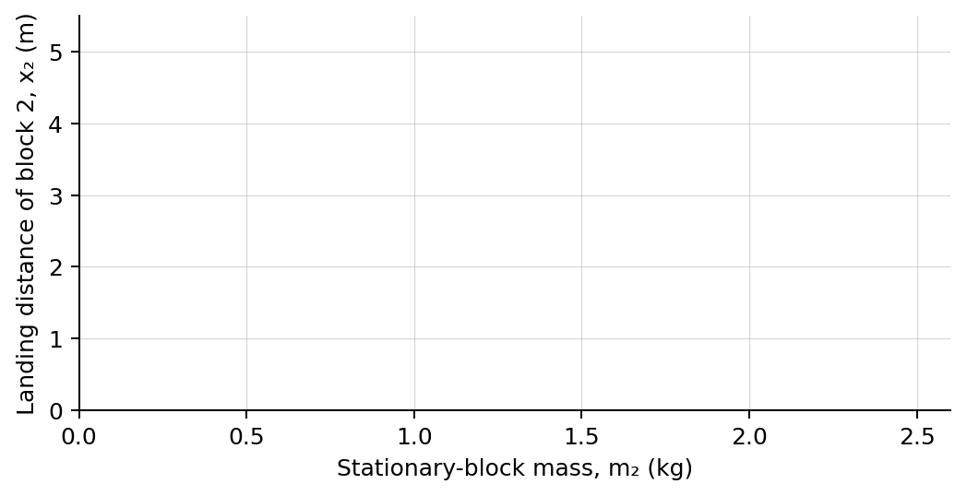
4. Plot block 2 landing distance versus its mass. Draw a smooth trend.
Analysis | 6 minutes
5. Compare calculated and measured baseline values. Which stage showed the greatest difference?
_______________________________________________________________________________________________
6. How did increasing m₂ affect both post-collision velocities?
_______________________________________________________________________________________________
7. Why do the landing distances depend directly on the horizontal post-collision velocities?
_______________________________________________________________________________________________
8. Identify which conservation principle applies to each stage: descent, collision, rebound, and projectile flight.
_______________________________________________________________________________________________
Claim-Evidence-Reasoning conclusion
Evaluate this claim: Because the collision is elastic, each block keeps its own kinetic energy during the collision.
CLAIM | Accept, reject, or revise the statement.
EVIDENCE | Cite at least two measured trials or graph features.
REASONING | Use total-system momentum and kinetic-energy evidence and distinguish system totals from individual values.
Exit ticket
For a horizontal projectile launched from the same table height, what single measured quantity determines horizontal landing distance?
_______________________________________________________________________________________________
_______________________________________________________________________________________________

