BUILD PHYSICS | GUIDED INVESTIGATION
RAMP, TABLE, AND PROJECTILE MOTION
Release height, launch speed, flight time, and horizontal range
Name: ____________________________ | Period: ____________ | Date: ______________

INVESTIGATION QUESTION How does release height affect table-edge speed and landing range?
TIME  30 minutes | SIMULATION  BuildPhysics > Ramp, table, and projectile motion | UNIT 3  Work, Energy & Power
Learning targets
• Use energy conservation to predict horizontal launch speed.
• Connect table height with projectile flight time.
• Test how release height changes horizontal range.
Model before you measure
The block starts from rest on a frictionless ramp, crosses a horizontal table, and leaves the edge horizontally. | mgΔh = ½mv_{x}² t = √(2H/g) R = v_{x}t
Important: Use g = 9.8 m/s². Keep table height H fixed in Part A, and measure release height relative to the table edge.
Pre-lab prediction | 4 minutes
1. If release height increases, what happens to table-edge speed?
__________________________________________________________________________________________
2. Should mass affect table-edge speed on a frictionless ramp?
__________________________________________________________________________________________
3. Does changing release height change the time of fall from the table?
__________________________________________________________________________________________

PART A Change release height
Setup | 3 minutes
□ Load Ramp, table, and projectile motion. Confirm the block starts from rest and friction is off.
□ Use the grid or displacement tool to place the block at four different release heights on the ramp.
□ Record the vertical release-height difference Δh above the table edge.
□ Reset, run through landing, and record edge speed, flight time, and horizontal range.
Same launch point: Every trial must leave the same table edge horizontally. Change only the block's release position.
Data table | 10 minutes
Trial | Release Δh  (m) | Predicted edge speed  (m/s) | Measured edge speed  (m/s) | Flight time  (s) | Range  (m)
1
2
3
4
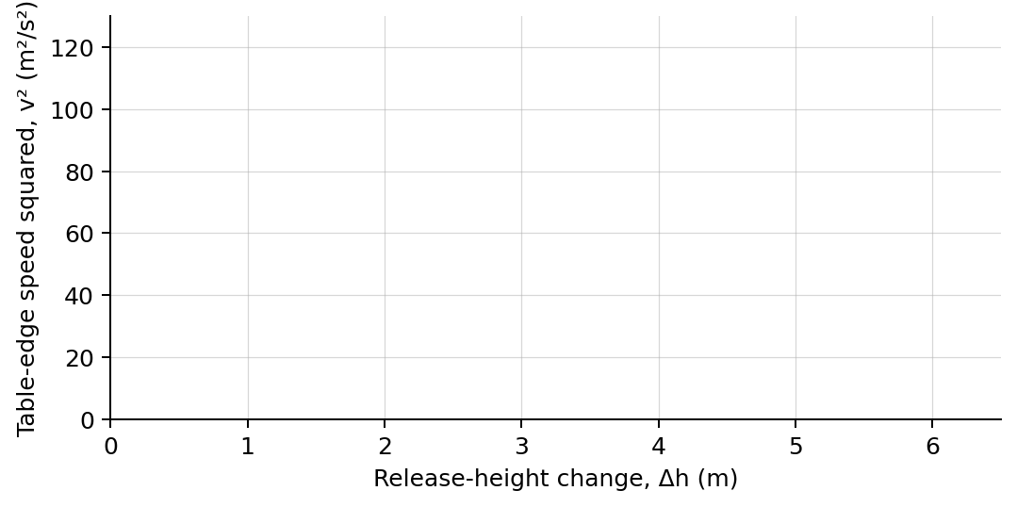
4. Plot measured edge speed squared versus release-height difference. Draw a best-fit line.

PART B Change mass at one release height
Mass test | 7 minutes
Controlled trial: Choose one release point from Part A and return the block to that same point after each mass change.
Mass  (kg) | Edge speed  (m/s) | Flight time  (s) | Range  (m)
1.0
2.0
4.0
Analysis | 7 minutes
5. What did the slope of the v²-versus-Δh graph represent? Compare with 2g.
_______________________________________________________________________________________________
6. Why did flight time remain nearly constant when release height changed?
_______________________________________________________________________________________________
7. How did changing mass affect edge speed, flight time, and range?
_______________________________________________________________________________________________
8. Explain why the mass cancels from the energy calculation.
_______________________________________________________________________________________________
Claim-Evidence-Reasoning conclusion
Evaluate this claim: A greater release height increases range because it increases both horizontal speed and flight time.
CLAIM | Accept, reject, or revise the statement.
EVIDENCE | Cite at least two measured trials or graph features.
REASONING | Connect your evidence to the energy model and controlled variables.
Exit ticket
If release-height difference is quadrupled while table height stays fixed, predict the factor by which edge speed and horizontal range change.
_______________________________________________________________________________________________
_______________________________________________________________________________________________

