BUILD PHYSICS | GUIDED INVESTIGATION
ENERGY IN A LOOP
Speed, gravitational potential energy, and maintaining contact
Name: ____________________________ | Period: ____________ | Date: ______________

INVESTIGATION QUESTION How do release height and position in the loop affect speed and contact force?
TIME  30 minutes | SIMULATION  BuildPhysics > Energy in a loop | UNIT 3  Work, Energy & Power
Learning targets
• Track energy at the bottom, side, and top of a vertical loop.
• Use energy conservation to predict speed changes.
• Determine the release condition needed to complete the loop.
Model before you measure
The car moves on a frictionless track. At the top, gravity and the normal force can both point toward the loop center. | E_{mech} = K + U_{g} Top: mg + F_{N} = mv_{top}²/r
Important: Use g = 9.8 m/s². A car remains in contact only while the track can exert a nonnegative normal force.
Pre-lab prediction | 4 minutes
1. Where should the car's speed be greatest: bottom, side, or top?
__________________________________________________________________________________________
2. At the top, what condition corresponds to the car being just barely in contact?
__________________________________________________________________________________________
3. Predict how increasing release height changes speed at the top.
__________________________________________________________________________________________

PART A Compare energy at four loop locations
Setup | 3 minutes
□ Load Energy in a loop. Keep friction off and turn on system energy totals.
□ Graph speed, kinetic energy, gravitational potential energy, and normal force.
□ Run and pause near the loop bottom, right side, top, and left side.
□ Record the car's height, speed, energies, and normal force at each position.
Data table | 10 minutes
Location | Height  (m) | Speed  (m/s) | Kinetic energy  (J) | Gravitational PE  (J) | Normal force  (N)
Bottom
Right side
Top
Left side
Position comparison | 3 minutes
4. Rank the four locations from greatest to least speed and explain using energy.
_______________________________________________________________________________________________
_______________________________________________________________________________________________

PART B Change release height and test loop completion
Release-height test | 8 minutes
Procedure: Move the car to several starting heights on the approach, release from rest, and record whether it remains on the track through the top.
Trial | Starting height  (m) | Completes loop? | Top speed  (m/s) | Top normal force  (N)
1
2
3
4
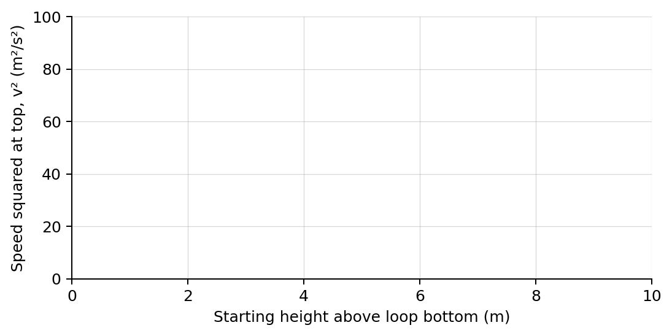
5. Plot top speed squared versus starting height for successful trials. Draw a best-fit line.
Analysis | 6 minutes
6. What did the slope of your graph represent?
_______________________________________________________________________________________________
7. Why was speed greatest at the bottom and least at the top?
_______________________________________________________________________________________________
8. What happened to the top normal force as release height was reduced?
_______________________________________________________________________________________________
9. Explain why a car can have nonzero speed at the top but still lose contact.
_______________________________________________________________________________________________
Claim-Evidence-Reasoning conclusion
Evaluate this claim: Any car that reaches the top of the loop will necessarily remain in contact with the track.
CLAIM | Accept, reject, or revise the statement.
EVIDENCE | Cite at least two measured trials or graph features.
REASONING | Connect your evidence to the energy model and controlled variables.
Exit ticket
At the top of a loop of radius r, write the minimum-speed condition for just maintaining contact.
_______________________________________________________________________________________________
_______________________________________________________________________________________________

