BUILD PHYSICS | GUIDED INVESTIGATION
ROLLING LAUNCH INTO PROJECTILE MOTION
Rotational inertia, horizontal launch speed, and projectile range
Name: ____________________________ | Period: ____________ | Date: ______________

INVESTIGATION QUESTION How does rotational inertia affect the range of a rolling object launched from the same height?
TIME  30 minutes | SIMULATION  BuildPhysics > Rolling launch into projectile motion | UNIT 6  Energy & Momentum of Rotating Systems
Learning targets
• Connect rolling energy on a ramp to horizontal launch speed.
• Compare the projectile ranges of a solid disk and a hoop.
• Separate the rolling stage from the airborne stage.
Model before you measure
The disk and hoop have equal mass, radius, release height, and track geometry. Both leave the same table edge horizontally. | mgh = ½mv_{x}² + ½Iω² t = √(2H/g) R = v_{x}t
Important: Use g = 9.8 m/s². The two objects have the same flight time when they leave the same height with zero initial vertical velocity.
Pre-lab prediction | 4 minutes
1. Which object should have the greater horizontal launch speed?
__________________________________________________________________________________________
2. Which object should land farther from the table?
__________________________________________________________________________________________
3. Predict whether the two objects have the same flight time.
__________________________________________________________________________________________

PART A Compare disk and hoop launches
Setup | 3 minutes
□ Load Rolling launch into projectile motion. Verify equal mass, radius, release height, and track geometry.
□ Turn on trails and graph speed, rotational kinetic energy, translational kinetic energy, and y-position.
□ Run both objects through the ramp and projectile flight. Record launch speed, flight time, and range.
□ Repeat at four equal release-height differences above the table edge.
Range measurement: Measure horizontal range from the table edge directly below the launch point to the first ground contact.
Data table | 10 minutes
Release Δh  (m) | Disk launch vₓ  (m/s) | Disk flight t  (s) | Disk range R  (m) | Hoop launch vₓ  (m/s) | Hoop flight t  (s) | Hoop range R  (m)
1.0
2.0
3.0
4.0
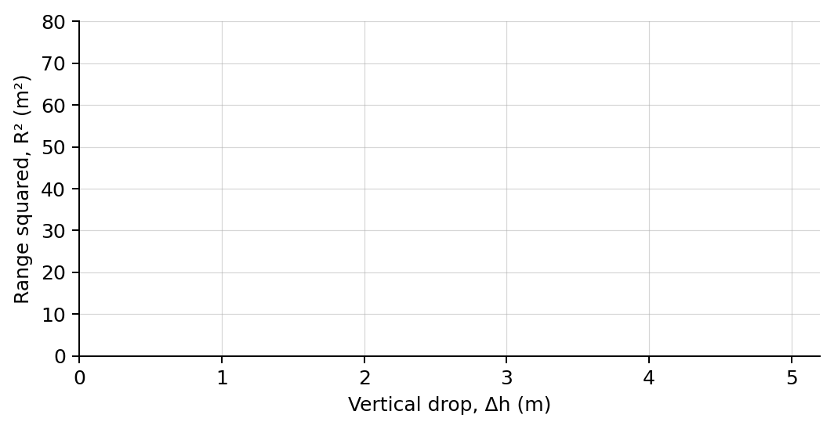
4. Plot R² versus Δh for both objects using different symbols. Draw one best-fit line for each.

PART B Change rotational inertia at fixed release height
Inertia-factor test | 7 minutes
Controlled trial: Choose one rolling object. Keep mass, radius, release height, and table height fixed while changing the inertia factor.
Inertia factor c | Launch speed vₓ  (m/s) | Flight time  (s) | Range  (m)
0.25
0.50
0.75
1.00
Analysis | 7 minutes
5. Why did the disk and hoop have nearly equal flight times but different ranges?
_______________________________________________________________________________________________
6. How did inertia factor affect launch speed and range?
_______________________________________________________________________________________________
7. Why is R² proportional to release-height difference for a fixed object and table height?
_______________________________________________________________________________________________
8. Identify the energy transformations during the ramp stage and the motion principles during the airborne stage.
_______________________________________________________________________________________________
Claim-Evidence-Reasoning conclusion
Evaluate this claim: The hoop lands closer because it experiences a smaller gravitational force than the solid disk.
CLAIM | Accept, reject, or revise the statement.
EVIDENCE | Cite at least two measured trials or graph features.
REASONING | Use rolling-energy partition, equal flight time, and horizontal launch speed.
Exit ticket
A rolling object leaves a table horizontally. If its launch speed is reduced by 20% while table height stays fixed, predict the change in range.
_______________________________________________________________________________________________
_______________________________________________________________________________________________

