BUILD PHYSICS | GUIDED INVESTIGATION
ROLLING OBJECTS
Translational and rotational energy on an incline
Name: ____________________________ | Period: ____________ | Date: ______________

INVESTIGATION QUESTION How does rotational inertia affect the acceleration and speed of a rolling object?
TIME  30 minutes | SIMULATION  BuildPhysics > Rolling objects | UNIT 6  Energy & Momentum of Rotating Systems
Learning targets
• Compare the motion of a solid disk and a hoop rolling without slipping.
• Track translational, rotational, and gravitational energy.
• Test how release height and mass affect bottom speed.
Model before you measure
The solid disk and hoop have equal mass, radius, and release conditions. Static friction enforces rolling without slipping but does no net mechanical work. | mgh = ½mv² + ½Iω² v = ωR I = cMR²
Important: Use g = 9.8 m/s². Keep mass, radius, release height, and track geometry equal when comparing shapes.
Pre-lab prediction | 4 minutes
1. Which should reach the bottom first: the solid disk or the hoop? Explain your prediction.
__________________________________________________________________________________________
2. Which object should have the greater translational speed at the bottom?
__________________________________________________________________________________________
3. Predict whether changing mass affects the bottom speed for the same shape and release height.
__________________________________________________________________________________________

PART A Compare a solid disk and a hoop
Setup | 3 minutes
□ Load Rolling objects. Verify that the disk and hoop have equal masses, radii, and release heights.
□ Turn on translational kinetic energy, rotational kinetic energy, gravitational potential energy, speed, and angular speed.
□ Reset and run both objects together. Record the arrival time and bottom values for each object.
□ Repeat at four different equal release heights while preserving identical track geometry.
Rolling check: At the bottom, verify that v ≈ ωR for each object before accepting the trial.
Data table | 10 minutes
Vertical drop Δh  (m) | Disk v  (m/s) | Disk arrival t  (s) | Disk Krot / Ktotal | Hoop v  (m/s) | Hoop arrival t  (s) | Hoop Krot / Ktotal
1.0
2.0
3.0
4.0
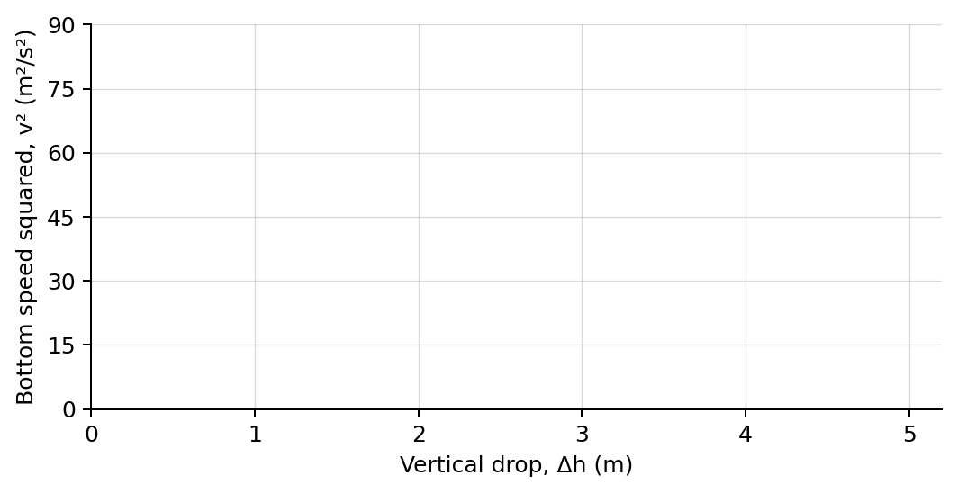
4. Plot v² versus Δh for both objects using different symbols. Draw one best-fit line for each.

PART B Change mass at fixed shape and height
Mass test | 7 minutes
Controlled trial: Use the solid disk at one release height. Keep radius, inertia factor, and track unchanged.
Mass  (kg) | Bottom speed  (m/s) | Arrival time  (s) | Total kinetic energy  (J)
1.0
2.0
4.0
6.0
Analysis | 7 minutes
5. How did the disk and hoop differ in bottom speed, arrival time, and energy distribution?
_______________________________________________________________________________________________
6. Why does the object with greater rotational inertia have less translational speed?
_______________________________________________________________________________________________
7. How did mass affect speed, time, and kinetic energy in Part B?
_______________________________________________________________________________________________
8. Explain why static friction can change the energy distribution without reducing total mechanical energy.
_______________________________________________________________________________________________
Claim-Evidence-Reasoning conclusion
Evaluate this claim: The hoop rolls down the ramp more slowly because it loses more mechanical energy to friction.
CLAIM | Accept, reject, or revise the statement.
EVIDENCE | Cite at least two measured trials or graph features.
REASONING | Use energy conservation, rotational inertia, and the rolling condition v = ωR.
Exit ticket
Two rolling objects have the same mass and radius. State which property determines how their kinetic energy is divided between translation and rotation.
_______________________________________________________________________________________________
_______________________________________________________________________________________________

