BUILD PHYSICS | GUIDED INVESTIGATION
ROTATIONAL INERTIA VERSUS ANGULAR ACCELERATION
Equal torque, mass distribution, and rotational response
Name: ____________________________ | Period: ____________ | Date: ______________

INVESTIGATION QUESTION For the same torque, how does angular acceleration depend on rotational inertia?
TIME  30 minutes | SIMULATION  BuildPhysics > Rotational inertia versus angular acceleration | UNIT 5  Torque & Rotational Dynamics
Learning targets
• Compare angular accelerations for objects with different mass distributions.
• Test the relationship α = τ/I.
• Determine how torque changes angular acceleration at fixed rotational inertia.
Model before you measure
A tangential force applied at radius r produces torque τ = rF. Rotational inertia measures resistance to angular acceleration. | Στ = Iα α = τ/I I = cMR²
Important: Keep torque constant in Part A. Record rotational inertia from the Object Inspector rather than assuming all objects have the same I.
Pre-lab prediction | 4 minutes
1. For equal mass and radius, which has greater rotational inertia: a solid disk or a hoop?
__________________________________________________________________________________________
2. Which should have greater angular acceleration under the same torque?
__________________________________________________________________________________________
3. If torque doubles at fixed I, what should happen to α?
__________________________________________________________________________________________

PART A Change rotational inertia at constant torque
Setup | 3 minutes
□ Load Rotational inertia versus angular acceleration. Confirm the two rotors receive equal tangential forces at equal radii.
□ Record mass, radius, inertia factor c, rotational inertia I, torque, and angular acceleration.
□ Create additional trials by changing one rotor's inertia factor or mass distribution while keeping torque fixed.
□ Reset and run briefly so the initial angular acceleration can be measured before large angular speeds develop.
Data table | 10 minutes
Rotor | Mass M  (kg) | Radius R  (m) | Inertia I  (kg·m²) | 1/I  (1/(kg·m²)) | Angular acceleration α  (rad/s²)
Solid disk
Hoop
Modified rotor 1
Modified rotor 2
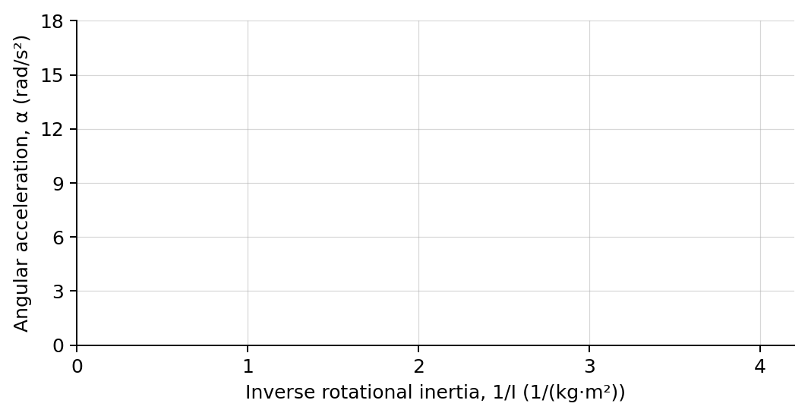
4. Plot angular acceleration versus inverse rotational inertia. Draw a best-fit line.

PART B Change torque at fixed rotational inertia
Torque test | 7 minutes
Fixed rotor: Choose one rotor and keep its mass, radius, and inertia factor unchanged. Change only the applied tangential force.
Trial | Applied force  (N) | Torque τ  (N·m) | Angular acceleration α  (rad/s²)
1
2
3
4
Analysis | 7 minutes
5. What should the slope of the α-versus-1/I graph represent?
_______________________________________________________________________________________________
6. How did moving mass farther from the axis affect I and α?
_______________________________________________________________________________________________
7. What relationship did Part B show between torque and angular acceleration?
_______________________________________________________________________________________________
8. Explain why equal masses and radii do not guarantee equal rotational inertia.
_______________________________________________________________________________________________
Claim-Evidence-Reasoning conclusion
Evaluate this claim: Objects with the same mass always have the same angular acceleration when the same torque is applied.
CLAIM | Accept, reject, or revise the statement.
EVIDENCE | Cite at least two measured trials or graph features.
REASONING | Use mass distribution, rotational inertia, and Στ = Iα.
Exit ticket
A rotor's rotational inertia doubles while applied torque stays constant. Predict the new angular acceleration relative to the original.
_______________________________________________________________________________________________
_______________________________________________________________________________________________

