BUILD PHYSICS | GUIDED INVESTIGATION
SKATER BOWL — CONSERVATION OF MECHANICAL ENERGY
Kinetic energy, gravitational potential energy, and turning points
Name: ____________________________ | Period: ____________ | Date: ______________

INVESTIGATION QUESTION Does total mechanical energy remain constant throughout the frictionless bowl?
TIME  30 minutes | SIMULATION  BuildPhysics > Skater bowl — conservation of mechanical energy | UNIT 3  Work, Energy & Power
Learning targets
• Compare kinetic and gravitational potential energy at key locations.
• Test whether total mechanical energy remains constant.
• Connect release height to speed at the bottom of the bowl.
Model before you measure
The skater starts from rest. Choose the preset's h = 0 reference at the lowest center-of-mass height. | E_{mech} = K + U_{g} = ½mv² + mgh
Important: Use g = 9.8 m/s². Friction and drag must remain off for the mechanical-energy model.
Pre-lab prediction | 4 minutes
1. At which location should kinetic energy be greatest?
__________________________________________________________________________________________
2. At a turning point, what is the skater's speed?
__________________________________________________________________________________________
3. Predict whether the skater reaches the same height on the opposite side.
__________________________________________________________________________________________

PART A Track energy during one complete pass
Setup | 3 minutes
□ Load Skater bowl — conservation of mechanical energy.
□ Open Energy and momentum totals and graph gravitational PE, kinetic energy, and total mechanical energy.
□ Run and pause near the starting point, bottom, opposite turning point, and bottom on the return.
□ Record height, speed, and energy values at each location.
Data table | 10 minutes
Location | Height h  (m) | Speed  (m/s) | Kinetic energy  (J) | Gravitational PE  (J) | Total mechanical energy  (J)
Starting point
Bottom
Opposite turning point
Bottom on return
Energy bar sketches | 3 minutes
Starting point | Bottom | Opposite turning point
Sketch K and gravitational PE | Sketch K and gravitational PE | Sketch K and gravitational PE

PART B Change release height
Release-height test | 8 minutes
Procedure: Move the skater to four different starting heights, release from rest, and record the vertical drop and bottom speed.
Trial | Starting height  (m) | Vertical drop Δh  (m) | Bottom speed  (m/s)
1
2
3
4
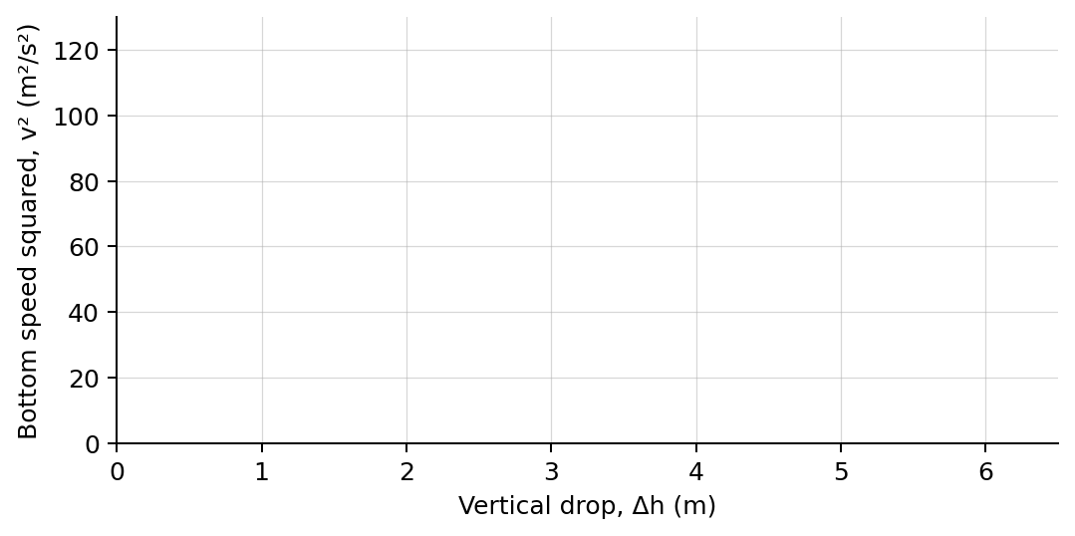
4. Plot bottom speed squared versus vertical drop. Draw a best-fit line.
Analysis | 6 minutes
5. How did kinetic and gravitational potential energy change between the top and bottom?
_______________________________________________________________________________________________
6. How constant was total mechanical energy across the four locations?
_______________________________________________________________________________________________
7. What should the slope of the v²-versus-Δh graph be? Explain.
_______________________________________________________________________________________________
8. Why did the skater return to approximately the original release height?
_______________________________________________________________________________________________
Claim-Evidence-Reasoning conclusion
Evaluate this claim: The skater has no acceleration at the bottom because gravitational potential energy is minimum there.
CLAIM | Accept, reject, or revise the statement.
EVIDENCE | Cite at least two measured trials or graph features.
REASONING | Connect your evidence to the energy model and controlled variables.
Exit ticket
A skater starts from rest 3.0 m above the bottom. Predict the speed at the bottom using g = 9.8 m/s².
_______________________________________________________________________________________________

