BUILD PHYSICS | GUIDED INVESTIGATION
IMPULSE WITH SPRING BUMPERS
Force-time area, momentum change, and collision duration
Name: ____________________________ | Period: ____________ | Date: ______________

INVESTIGATION QUESTION How can two bumpers produce similar impulses but different peak forces and contact times?
TIME  30 minutes | SIMULATION  BuildPhysics > Impulse with spring bumpers | UNIT 4  Linear Momentum
Learning targets
• Relate force-time area to momentum change.
• Compare soft and stiff bumpers during otherwise similar collisions.
• Explain the tradeoff between peak force and collision duration.
Model before you measure
Impulse is the signed area under a force-versus-time graph. For one cart, impulse equals its momentum change. | J_{x} = Area of F vs t graph = Δp_{x} = m(v_{f} − v_{i})
Important: Use the graph Area tool on Spring force x. Record the sign consistently or compare magnitudes throughout.
Pre-lab prediction | 4 minutes
1. Which bumper should have the larger peak force: soft or stiff?
__________________________________________________________________________________________
2. Which bumper should have the longer collision time?
__________________________________________________________________________________________
3. Predict whether the two impulses will be similar for equal initial and final speeds.
__________________________________________________________________________________________

PART A Compare the preset soft and stiff bumpers
Setup | 3 minutes
□ Load Impulse with spring bumpers. Record both cart masses and initial speeds.
□ Select one cart and graph Spring force x and pₓ.
□ Run each cart through its bumper collision and use the Area tool over the full contact interval.
□ Record force-time area, peak force, collision duration, and momentum change.
Data table | 10 minutes
Bumper | vᵢ  (m/s) | v_f  (m/s) | Δpₓ  (N·s) | Force-time area Jₓ  (N·s) | Peak |Fₓ|  (N) | Contact time  (s)
Soft bumper
Stiff bumper
Force-time sketches | 3 minutes
Soft bumper force-time shape | Stiff bumper force-time shape

PART B Change initial speed
Speed test | 8 minutes
Controlled trial: Use the same bumper and cart mass. Change only the incoming speed.
Incoming speed  (m/s) | Outgoing speed  (m/s) | |Δpₓ|  (N·s) | |Jₓ|  (N·s) | Peak force  (N)
1.0
2.0
3.0
4.0
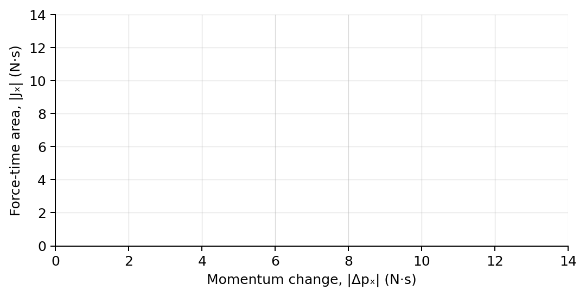
4. Plot force-time area magnitude versus momentum-change magnitude. Draw a best-fit line.
Analysis | 6 minutes
5. Compare the two preset bumpers' impulses, peak forces, and collision times.
_______________________________________________________________________________________________
6. What should the slope of the J-versus-Δp graph be?
_______________________________________________________________________________________________
7. How did incoming speed affect impulse and peak force?
_______________________________________________________________________________________________
8. Explain how a longer collision time can reduce peak force while producing the same momentum change.
_______________________________________________________________________________________________
Claim-Evidence-Reasoning conclusion
Evaluate this claim: A softer bumper reduces impulse because it reduces the peak force.
CLAIM | Accept, reject, or revise the statement.
EVIDENCE | Cite at least two measured trials or graph features.
REASONING | Use force-time area and momentum-change evidence, not peak force alone.
Exit ticket
An air bag increases the stopping time of a passenger. Explain what happens to impulse and average force.
_______________________________________________________________________________________________
_______________________________________________________________________________________________

