BUILD PHYSICS | GUIDED INVESTIGATION
SPRING LAUNCH UP A CURVED RAMP
Elastic energy, gravitational potential energy, and turning-point height
Name: ____________________________ | Period: ____________ | Date: ______________

INVESTIGATION QUESTION Is maximum vertical height proportional to the square of spring compression?
TIME  30 minutes | SIMULATION  BuildPhysics > Spring launch up a curved ramp | UNIT 3  Work, Energy & Power
Learning targets
• Track energy from a compressed spring to a gravitational turning point.
• Test the relationship between compression squared and maximum height.
• Determine how projectile mass changes the turning-point height.
Model before you measure
The projectile begins from rest against the launcher and momentarily stops at its highest point. Friction and drag are off. | ½kx² = mgΔh Δh = kx²/(2mg)
Important: Use g = 9.8 m/s². Measure Δh from the projectile's starting center to its maximum center height.
Pre-lab prediction | 4 minutes
1. If compression doubles, by what factor should maximum vertical rise change?
__________________________________________________________________________________________
2. At the turning point, what are the projectile's kinetic energy and speed?
__________________________________________________________________________________________
3. Predict how doubling mass affects maximum rise at fixed compression.
__________________________________________________________________________________________

PART A Change compression and measure maximum rise
Setup | 3 minutes
□ Load Spring launch up a curved ramp. Confirm friction is off.
□ Select the launcher and record k. Set each compression by changing natural length.
□ Graph y-position, kinetic energy, spring energy, and gravitational potential energy.
□ Reset, run until the projectile turns around, pause, and record the maximum center height.
Measurement: Record the initial center height once, then calculate Δh = y_max − y_initial for each trial.
Data table | 10 minutes
Compression x  (m) | x²  (m²) | Spring energy  (J) | Maximum y  (m) | Vertical rise Δh  (m)
0.75
1.25
1.75
2.25
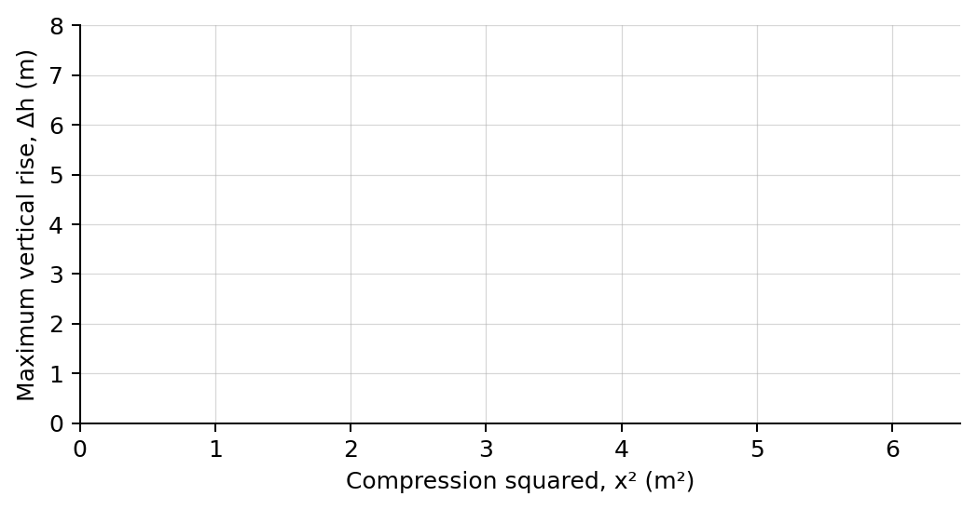
4. Plot maximum vertical rise versus compression squared. Draw a best-fit line.

PART B Change mass at fixed compression
Mass test | 7 minutes
Fixed input: Use x = 1.75 m and keep k and the ramp geometry unchanged.
Mass  (kg) | Predicted Δh  (m) | Measured Δh  (m)
2.5
5.0
7.5
10.0
Analysis | 7 minutes
5. What relationship did your graph show between Δh and x²?
_______________________________________________________________________________________________
6. What physical quantity should the graph's slope represent?
_______________________________________________________________________________________________
7. How did mass affect maximum height at fixed compression?
_______________________________________________________________________________________________
8. Describe the energy transformations from release to the turning point.
_______________________________________________________________________________________________
Claim-Evidence-Reasoning conclusion
Evaluate this claim: Maximum vertical rise is directly proportional to spring compression.
CLAIM | Accept, reject, or revise the statement.
EVIDENCE | Cite at least two measured trials or graph features.
REASONING | Connect your evidence to the energy model and controlled variables.
Exit ticket
A launcher with the same k fires the same mass with twice the compression. Predict the new maximum vertical rise relative to the original.
_______________________________________________________________________________________________
_______________________________________________________________________________________________

