BUILD PHYSICS | GUIDED INVESTIGATION
SPRING-LAUNCHED PROJECTILE
Elastic potential energy, launch speed, and projectile range
Name: ____________________________ | Period: ____________ | Date: ______________

INVESTIGATION QUESTION Is horizontal range directly proportional to spring compression?
TIME  30 minutes | SIMULATION  BuildPhysics > Spring-launched projectile | UNIT 3  Work, Energy & Power
Learning targets
• Relate spring compression to elastic potential energy and launch speed.
• Test how compression changes horizontal projectile range.
• Separate the launch-energy stage from the projectile-motion stage.
Model before you measure
The launcher has spring constant k and compression x. The projectile leaves the table horizontally. Use the custom h = 0 reference shown in the preset. | U_{s} = ½kx² ½kx² = ½mv² R = v_{x}t
Important: Use g = 9.8 m/s². Keep mass, k, table height, and launch height constant in Part A. Reset before each run.
Pre-lab prediction | 4 minutes
1. If compression doubles, by what factor does the spring's stored energy change?
__________________________________________________________________________________________
2. Predict how launch speed depends on compression.
__________________________________________________________________________________________
3. Predict whether flight time changes when only compression changes.
__________________________________________________________________________________________

PART A Change spring compression
Setup | 3 minutes
□ Load Spring-launched projectile. Confirm friction is off and the projectile mass is 5.0 kg.
□ Select the launcher and record k. Change the natural length to create the listed compression.
□ Graph speed and horizontal position. Turn on Energy and momentum totals.
□ Reset, run through the landing, and record the table-edge speed, flight time, and horizontal range.
Consistent trials: Measure compression immediately before release. Use the same table edge and landing-height reference in every trial.
Data table | 10 minutes
Compression x  (m) | x²  (m²) | Spring energy  (J) | Edge speed  (m/s) | Flight time  (s) | Range R  (m)
0.75
1.25
1.75
2.25
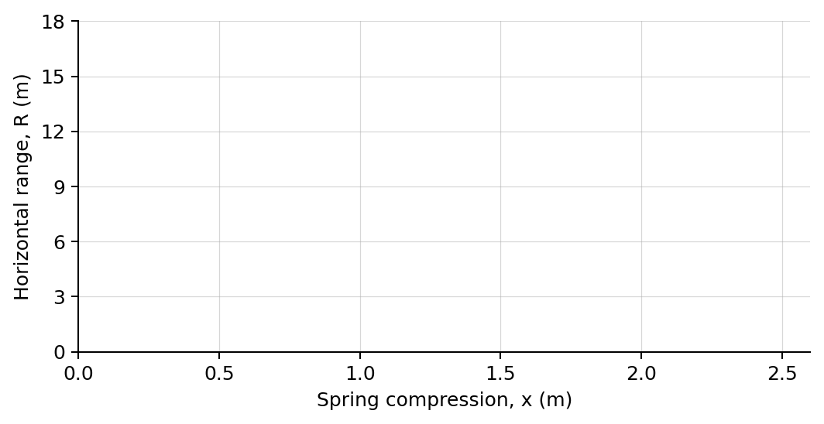
4. Plot horizontal range versus compression. Draw a best-fit line.

PART B Change mass at fixed compression
Mass test | 7 minutes
Fixed input: Choose one compression from Part A and keep k and the table geometry unchanged.
Projectile mass  (kg) | Measured edge speed  (m/s) | Measured range  (m)
2.5
5.0
7.5
10.0
Analysis | 7 minutes
5. Was range directly proportional to compression? Use your graph and at least two trials.
_______________________________________________________________________________________________
6. Why was flight time approximately constant in Part A?
_______________________________________________________________________________________________
7. How did increasing mass affect edge speed and range at fixed compression?
_______________________________________________________________________________________________
8. Explain why the energy equation predicts v is proportional to x when k and m are constant.
_______________________________________________________________________________________________
Claim-Evidence-Reasoning conclusion
Evaluate this claim: Doubling spring compression doubles the projectile's horizontal range.
CLAIM | Accept, reject, or revise the statement.
EVIDENCE | Cite at least two measured trials or graph features.
REASONING | Connect your evidence to the energy model and controlled variables.
Exit ticket
A spring is compressed three times as far while k, mass, and table height stay fixed. Predict the factors by which spring energy, launch speed, and range change.
_______________________________________________________________________________________________
_______________________________________________________________________________________________

