BUILD PHYSICS | GUIDED INVESTIGATION
ROTATIONAL EQUILIBRIUM
Force, lever arm, torque, and balance
Name: ____________________________ | Period: ____________ | Date: ______________

INVESTIGATION QUESTION How do mass and distance from a pivot determine rotational equilibrium?
TIME  30 minutes | SIMULATION  BuildPhysics > Rotational equilibrium | UNIT 5  Torque & Rotational Dynamics
Learning targets
• Calculate clockwise and counterclockwise torques about a pivot.
• Determine the balancing position for different masses.
• Distinguish zero net torque from zero individual torque.
Model before you measure
Choose the pivot as the torque axis. The riders' weights act downward at different lever arms. | τ = rF sinθ Στ = 0 m₁gr₁ = m₂gr₂
Important: Use g = 9.8 m/s². Measure each horizontal distance from the pivot to the rider's center of mass.
Pre-lab prediction | 4 minutes
1. If one rider moves twice as far from the pivot, how must that rider's mass change to keep balance?
__________________________________________________________________________________________
2. Can the beam be balanced while both riders exert nonzero torques? Explain.
__________________________________________________________________________________________
3. Predict the rotation direction if clockwise torque is greater than counterclockwise torque.
__________________________________________________________________________________________

PART A Find the balancing position
Setup | 3 minutes
□ Load Rotational equilibrium. Pause the simulation and record the left rider's mass and distance from the pivot.
□ Keep the left rider fixed. Change the right rider's mass to each listed value.
□ Move the right rider until the beam remains level with negligible angular acceleration.
□ Record the balancing distance and calculate both torque magnitudes using g = 9.8 m/s².
Balance criterion: The beam is in rotational equilibrium when it remains level and the clockwise and counterclockwise torque magnitudes are equal.
Data table | 10 minutes
Right mass m₂  (kg) | 1/m₂  (1/kg) | Balance distance r₂  (m) | Left torque  (N·m) | Right torque  (N·m) | Net torque  (N·m)
0.50
0.75
1.00
1.50
2.00
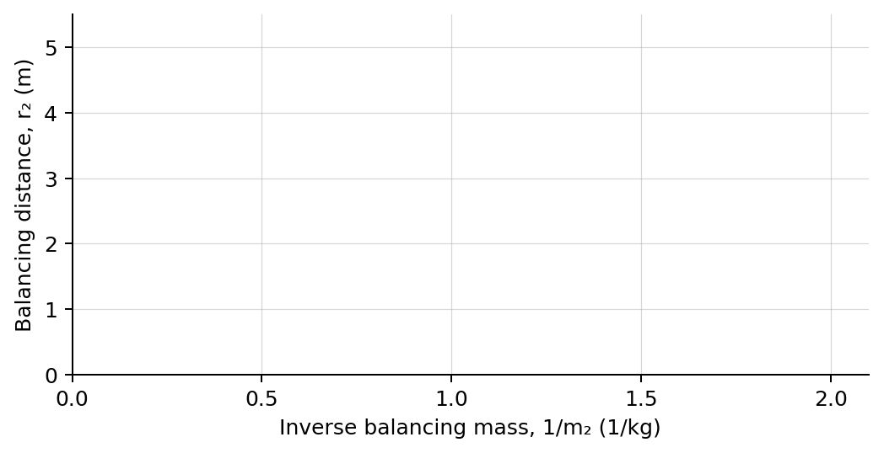
4. Plot balancing distance r₂ versus 1/m₂. Draw a best-fit line.

PART B Create controlled torque imbalances
Torque-direction test | 7 minutes
Procedure: Begin from one balanced trial. Move only the right rider by the listed amount, reset, and record the initial angular acceleration.
Right-rider position | Net torque direction | Initial α  (rad/s²) | Observed rotation
0.50 m closer
0.25 m closer
Balanced position
0.25 m farther
0.50 m farther
Analysis | 7 minutes
5. What physical quantity should the slope of the r₂-versus-1/m₂ graph represent?
_______________________________________________________________________________________________
6. How closely did the two torque magnitudes agree in balanced trials?
_______________________________________________________________________________________________
7. How did the sign of net torque relate to the sign of angular acceleration?
_______________________________________________________________________________________________
8. Explain why equal downward forces do not necessarily produce equal torques.
_______________________________________________________________________________________________
Claim-Evidence-Reasoning conclusion
Evaluate this claim: A beam is balanced whenever the forces on the two sides are equal.
CLAIM | Accept, reject, or revise the statement.
EVIDENCE | Cite at least two measured trials or graph features.
REASONING | Use lever arms, torque direction, and the rotational-equilibrium condition.
Exit ticket
A 60 kg rider sits 2.0 m left of a pivot. Where should a 40 kg rider sit on the right to balance the beam?
_______________________________________________________________________________________________
_______________________________________________________________________________________________

