BUILD PHYSICS | GUIDED INVESTIGATION
UNIFORM CIRCULAR MOTION
Centripetal acceleration, string tension, speed, and mass
Name: ____________________________ | Period: ____________ | Date: ______________

INVESTIGATION QUESTION How does the required centripetal force depend on tangential speed?
TIME  30 minutes | SIMULATION  BuildPhysics > Uniform circular motion | UNIT 2  Force & Translational Dynamics
Learning targets
• Measure tension and inward acceleration during uniform circular motion.
• Test the v² dependence of centripetal force.
• Test how mass changes force while speed and radius remain fixed.
Model before you measure
Gravity is off. The string tension is the inward net force. The baseline radius is 3.0 m and the baseline mass is 1.0 kg. | a_{c} = v²/r F_{c} = mv²/r
Important: The velocity is tangent to the circle while acceleration and tension point toward the center. No value of g is needed because gravity is off.
Pre-lab prediction | 4 minutes
1. If speed doubles, by what factor should tension change?
__________________________________________________________________________________________
2. If mass doubles at the same speed and radius, what should happen to tension?
__________________________________________________________________________________________
3. Are velocity and acceleration parallel in uniform circular motion? Explain.
__________________________________________________________________________________________

PART A Change speed at fixed mass and radius
Setup | 3 minutes
□ Load Uniform circular motion. Keep m = 1.0 kg and r = 3.0 m.
□ Select the moving mass and set its tangential velocity to the listed speed.
□ Graph tension, acceleration magnitude, and speed. Reset before each trial.
□ Run for at least one revolution and record the steady values.
Tangential direction: At the starting point to the right of the pivot, set vₓ = 0 and vᵧ equal to the listed positive speed.
Data table | 10 minutes
v  (m/s) | v²  (m²/s²) | Predicted T = mv²/r  (N) | Measured T  (N) | Measured |a|  (m/s²)
2 | 4
3 | 9
4 | 16
5 | 25
6 | 36
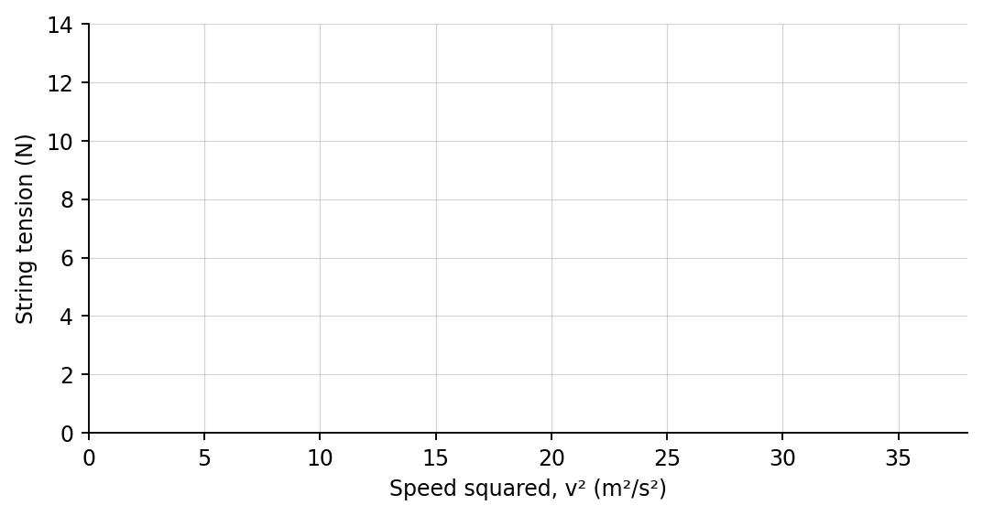
4. Plot measured tension versus v². Draw a best-fit line.

PART B Change mass and radius
Mass test | 5 minutes
Fixed motion: Use v = 4.0 m/s and r = 3.0 m.
Mass  (kg) | Predicted T  (N) | Measured T  (N)
0.50
1.00
1.50
2.00
Radius challenge | 3 minutes
Use m = 1.0 kg and v = 4.0 m/s. Compare r = 2.0 m and r = 4.0 m. Record T₂m = __________ N and T₄m = __________ N.
Analysis | 7 minutes
5. What did the slope of the T-versus-v² graph represent?
_______________________________________________________________________________________________
6. How did tension change with mass? How did it change with radius?
_______________________________________________________________________________________________
7. Why can speed remain constant while velocity changes continuously?
_______________________________________________________________________________________________
8. Compare the direction of tension, acceleration, and velocity at one point on the path.
_______________________________________________________________________________________________
Claim-Evidence-Reasoning conclusion
Evaluate this statement: “Doubling an object's speed in a circle doubles the required centripetal force.”
CLAIM | Accept, reject, or revise the statement.
EVIDENCE | Cite at least two measurements or graph features.
REASONING | Connect your evidence to the force model and Newton's laws.
Exit ticket
A 2.0 kg object moves at 6.0 m/s in a circle of radius 3.0 m. Determine its centripetal acceleration and net force.
____________________________________________________________________________________________
____________________________________________________________________________________________

