BUILD PHYSICS | GUIDED INVESTIGATION
2D VECTOR DISPLACEMENT SCAVENGER HUNT
Components, tip-to-tail addition, and resultant displacement
Name: ____________________________ | Period: __________ | Date: ____________

INVESTIGATION QUESTION How do the components of ten connected displacement vectors determine the treasure location?
TIME  30 minutes | SIMULATION  BuildPhysics > 2D Vector Displacement Scavenger Hunt | UNIT 1  Kinematics
Learning targets
• Construct displacement vectors tip to tail from written magnitude-direction clues.
• Resolve each displacement into Δx and Δy components.
• Add components to determine the final position and resultant displacement.
Model before you measure
Angles are measured from the named reference direction.  Use signs to show east/west and north/south components. | Component model  Δx = d cos θ  Δy = d sin θ  R = √[(ΣΔx)² + (ΣΔy)²]
Precision: The BuildPhysics tutorial checks the start point, magnitude, and direction before unlocking the next clue. Begin at (0, 0) and connect every vector tip to tail.
Pre-lab prediction | 4 minutes
1. Explain why the final displacement is not necessarily equal to the total distance traveled.
______________________________________________________________________________________________
2. What do positive and negative component signs represent in this coordinate system?
______________________________________________________________________________________________

PART A Follow the clues and record components
Setup | 2 minutes
□ Load 2D Vector Displacement Scavenger Hunt. The guided sequence begins automatically.
□ Use Measure Displacement for every clue. Record each vector after BuildPhysics verifies it.
□ Show vector values, angles in degrees, and x/y components while collecting data.
Clue | d  (m) | Direction | Δx  (m) | Δy  (m) | Cumulative x  (m) | Cumulative y  (m)
1 | 5.0 | East
2 | 4.0 | 30° N of E
3 | 3.0 | North
4 | 4.0 | 45° N of W
5 | 2.0 | West
Clue | d  (m) | Direction | Δx  (m) | Δy  (m) | Cumulative x  (m) | Cumulative y  (m)
6 | 5.0 | 30° S of W
7 | 3.0 | South
8 | 4.0 | 60° S of E
9 | 2.0 | East
10 | 3.0 | 30° N of E
3. After clue 10, record the treasure coordinates shown by BuildPhysics.
______________________________________________________________________________________________

PART B Determine the resultant and analyze
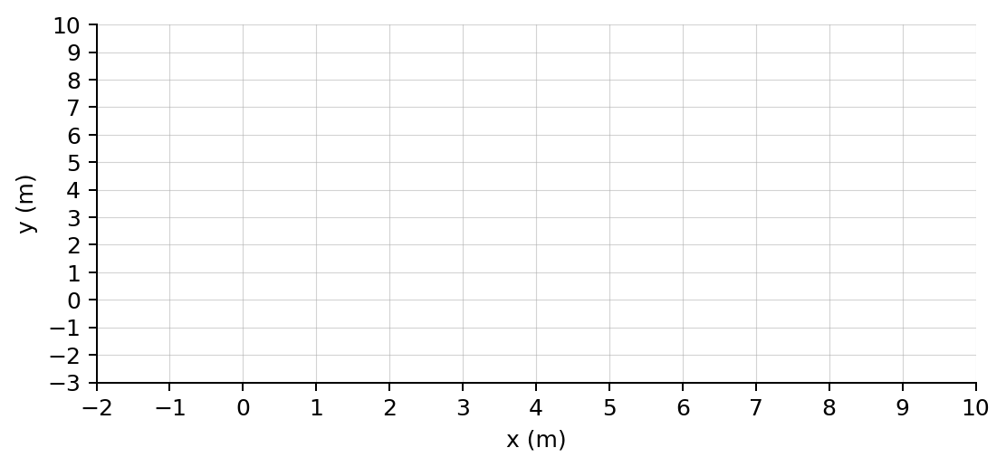
Sketch the complete tip-to-tail path and draw one resultant from the origin to the treasure.
Resultant calculations | 7 minutes
ΣΔx  (m) | ΣΔy  (m) | Calculated R  (m) | Calculated direction | Measured R  (m) | Measured direction
4. Compare the sum of the ten magnitudes with the resultant magnitude. Why are they different?
______________________________________________________________________________________________
5. Which clues caused the largest changes in cumulative x? Which caused the largest changes in cumulative y?
______________________________________________________________________________________________
______________________________________________________________________________________________
6. If clue 6 were changed from 5.0 m to 6.0 m in the same direction, predict the new final x and y coordinates.
______________________________________________________________________________________________
______________________________________________________________________________________________
7. Explain how the final position could be found without drawing the entire path to scale.
______________________________________________________________________________________________
Claim-Evidence-Reasoning conclusion
Evaluate this statement: “When vectors are connected tip to tail, their magnitudes can be added directly to find the resultant magnitude.”
CLAIM | Accept, reject, or revise the statement.
EVIDENCE | Cite at least two measurements or graph features.
REASONING | Connect your evidence to the kinematics model.
Exit ticket
A path ends at (−4.0 m, +3.0 m). Determine the resultant magnitude and describe its quadrant direction.
______________________________________________________________________________________________
______________________________________________________________________________________________

