BUILD PHYSICS | GUIDED INVESTIGATION
VERTICAL CIRCULAR MOTION
Changing speed, tension, and the condition for a taut string
Name: ____________________________ | Period: ____________ | Date: ______________

INVESTIGATION QUESTION How do speed and string tension vary between the bottom and top of a vertical circle?
TIME  30 minutes | SIMULATION  BuildPhysics > Vertical circular motion | UNIT 2  Force & Translational Dynamics
Learning targets
• Compare speed and tension at multiple locations in a vertical circle.
• Apply radial Newton's second law at the top and bottom.
• Find the minimum starting speed needed to keep the string taut.
Model before you measure
The baseline has m = 1.0 kg, r = 2.5 m, and a bottom speed of 14 m/s. Choose inward as the positive radial direction. | Bottom: T − mg = mv²/r Top: T + mg = mv²/r
Important: Use g = 9.8 m/s². A string can pull but cannot push, so its tension cannot be negative.
Pre-lab prediction | 4 minutes
1. At which location should the object move fastest: top or bottom? Explain.
__________________________________________________________________________________________
2. At which location should string tension be greatest?
__________________________________________________________________________________________
3. What does it mean physically if a calculation predicts negative string tension?
__________________________________________________________________________________________

PART A Compare four locations in one complete circle
Setup | 3 minutes
□ Load Vertical circular motion. Keep m = 1.0 kg, r = 2.5 m, and initial bottom speed = 14 m/s.
□ Graph string tension, speed, and y-position.
□ Run and pause near the bottom, right side, top, and left side.
□ Record the speed and tension at each location. Repeat if needed for cleaner readings.
Data table | 10 minutes
Location | y − yₚ  (m) | Measured speed  (m/s) | Measured tension  (N)
Bottom | −2.5
Right side | 0
Top | +2.5
Left side | 0
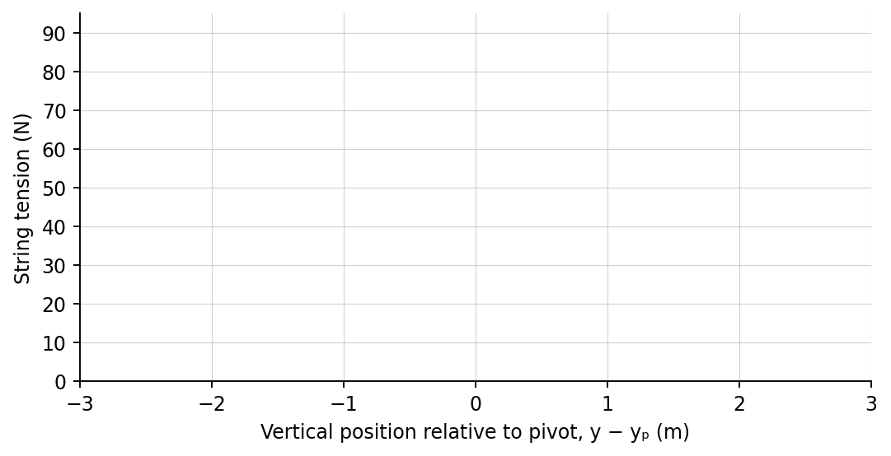
4. Plot tension versus vertical position using the four measurements. Sketch the trend.

PART B Lower the starting speed and test string contact
Minimum-speed test | 7 minutes
Starting condition: Return the mass to the bottom before every trial. Change only the initial horizontal speed.
Initial bottom speed  (m/s) | Completes circle? | Speed near top  (m/s) | Minimum tension  (N)
14.0
12.0
11.0
10.0
Predicted minimum bottom speed for a taut string: v = √(5gr) = __________________ m/s.
Analysis | 7 minutes
5. Why was the object faster at the bottom than at the top?
_______________________________________________________________________________________________
6. Use radial force equations to explain why tension is greater at the bottom.
_______________________________________________________________________________________________
7. How did the simulation indicate that the string became slack?
_______________________________________________________________________________________________
8. Compare your experimental threshold with √(5gr).
_______________________________________________________________________________________________
Claim-Evidence-Reasoning conclusion
Evaluate this statement: “The string tension is constant during vertical circular motion because the radius is constant.”
CLAIM | Accept, reject, or revise the statement.
EVIDENCE | Cite at least two measurements or graph features.
REASONING | Connect your evidence to the force model and Newton's laws.
Exit ticket
At the top of a vertical circle, what minimum speed is required for a string of radius r to remain just taut? Express the result using g and r.
____________________________________________________________________________________________
____________________________________________________________________________________________

