BUILD PHYSICS | GUIDED INVESTIGATION
STATIC TORQUE BALANCE
Wall-supported beam, hinge forces, and support-rope tension
Name: ____________________________ | Period: ____________ | Date: ______________

INVESTIGATION QUESTION How does support-rope angle affect the tension required for rotational equilibrium?
TIME  30 minutes | SIMULATION  BuildPhysics > Static torque balance | UNIT 5  Torque & Rotational Dynamics
Learning targets
• Apply the rotational-equilibrium condition to a supported beam.
• Determine how rope angle changes the torque produced by tension.
• Interpret the slope of a transformed tension graph.
Model before you measure
Take torques about the wall hinge so the unknown hinge forces produce no torque. The beam's weight acts at its center of mass. | Στ_{hinge} = 0 Tr_{T}sinθ = mg r_{cm}
Important: Use g = 9.8 m/s². Keep beam mass, beam angle, and rope attachment point fixed in Part A.
Pre-lab prediction | 4 minutes
1. As the rope becomes more horizontal, should the required tension increase or decrease?
__________________________________________________________________________________________
2. What part of the tension produces torque about the hinge?
__________________________________________________________________________________________
3. Why is choosing the hinge as the torque axis useful?
__________________________________________________________________________________________

PART A Change rope angle
Setup | 3 minutes
□ Load Static torque balance. Record beam mass, center-of-mass distance, and rope attachment distance from the hinge.
□ Keep the beam fixed in its original orientation.
□ Change the rope geometry to create the listed angles between the rope and the beam.
□ Run briefly, pause, and record rope tension and the hinge-force components.
Angle measurement: Measure θ between the rope and the beam, not between the rope and the horizontal.
Data table | 10 minutes
Rope angle θ | sin θ | 1/sin θ | Measured tension T  (N) | Calculated T  (N) | Hinge-force magnitude  (N)
20°
30°
40°
50°
60°
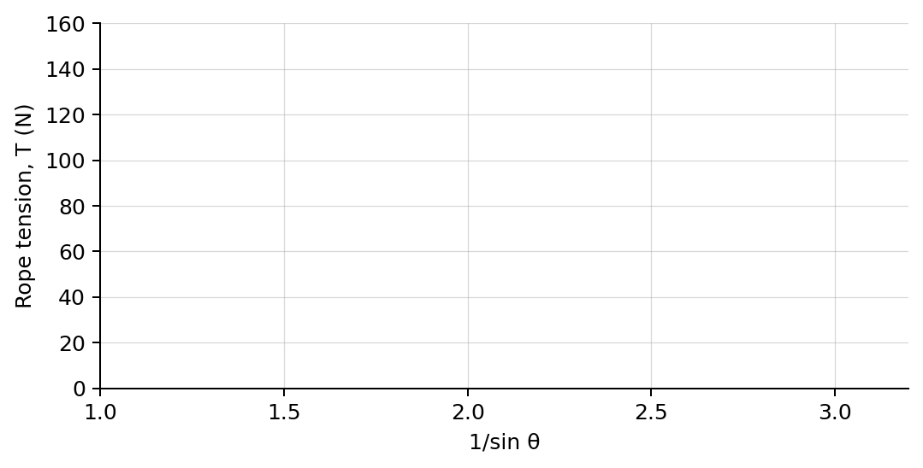
4. Plot measured rope tension versus 1/sin θ. Draw a best-fit line.

PART B Change beam mass
Mass test | 7 minutes
Fixed geometry: Choose one rope angle from Part A and keep all distances and angles constant.
Beam mass  (kg) | Beam weight  (N) | Measured tension  (N) | T / m  (N/kg)
2.0
4.0
6.0
8.0
Analysis | 7 minutes
5. Why did tension increase as the rope became more horizontal?
_______________________________________________________________________________________________
6. What physical combination should the slope of the T-versus-1/sin θ graph represent?
_______________________________________________________________________________________________
7. How did beam mass affect rope tension at fixed geometry?
_______________________________________________________________________________________________
8. Why do the hinge forces not appear in the torque equation about the hinge?
_______________________________________________________________________________________________
Claim-Evidence-Reasoning conclusion
Evaluate this claim: A support rope produces the same torque whenever its tension is unchanged.
CLAIM | Accept, reject, or revise the statement.
EVIDENCE | Cite at least two measured trials or graph features.
REASONING | Use the perpendicular component of tension, the lever arm, and Στ = 0.
Exit ticket
A rope attached to a beam is moved to a smaller angle while all other variables stay fixed. Predict what happens to the required tension.
_______________________________________________________________________________________________
_______________________________________________________________________________________________

